Profile of Busan

Ⅰ. General information

Busan, a bustling city of approximately 3.7 million residents, is located on the Southeastern tip of the Korean peninsula. The size of Busan is 763.3km2 which is 0.8% of the whole land of the Korean Peninsula. The natural environment of Busan is a perfect example of harmony between mountains, rivers and sea. Its geography includes a coastline with superb beaches and scenic cliffs, mountains which provide excellent hiking and extraordinary vista, and hot springs scattered throughout the city. Busan enjoys four distinct seasons and a temperate climate that never gets too hot or too cold.
Busan is the second largest city in Korea. Its deep harbor and gentle tides have allowed it to grow into the largest container handling port in the country and the third largest in the world, with potential for even more growth. Its natural endowments and rich history have resulted in Busan's increasing reputation as a world class city of tourism and culture.
Busan presents an ambitious vision of developing into the Pan-Pacific hub port for the international exchanges and activities, as well as the capital port of Korea. For this purpose, Busan is promoting the so-called Three Millennium Projects, which involve classifying the city into three areas Central Busan, East Busan and West Busan areas and extensively developing the East Busan and West Busan areas Central Busan, East Busan and West Busan areas and Centum City. In addition, the city plans to promote its tourism by providing intensive support to industries like film and visual arts. All of these are in accordance with the city's much broader vision of developing into a global city, a city of culture and a marine capital. Busan plans to designate the development areas of East Busan, West Busan and Centum City a special economic zone with a broader vision of developing it into a business heartland.

1. History

July 1407 | ▪ Opening of Busan-Po(=Busan Port) for the first time.
Feb. 1876 | ▪ Opening the Busan Port as an International Port.
Feb. 1895 | ▪ Renamed Dongnae-Bu.
Oct. 1910 | ▪ Renamed Busan-Bu.
Oct. 1914 | ▪ Execution of the Busan-Bu System.
Apr. 1936 | ▪ The 1st Administrative District Expansion.  (Seomyeon Dongnae-gu, Amnamni Saha-myeon were incorporated into Busan)
Oct. 1942 | ▪ The 2nd Administrative District Expansion.  (Dongnae-eup Dongnae-gun, Saha-myeon were incorporated into Busan)
Aug. 1949 | ▪ Changed the name from Busan-Bu to Busan City. (Population : 470,000 people)
Jan. 1957 | ▪ Execution of the Gu(Administrative District Unit) System.  ▪ 6 Gu (Jung-gu, Seo-gu, Dong-gu, Yeongdo-gu, Busanjin-gu, Dongnae-gu)
Jan. 1963 | ▪ Changed to the Government Jighalsi (City under the Direct Control of the Government),  6 Gu 7 Branch Office. (Population : 1,360,000 people)  ▪ The 3rd Administrative District Expansion.  (Gupo-eup Dongnae-gun, Sasang-myeon, Book-myeon, Gijang-myeon, Songjeongni  were incorporated into Busan)
Oct. 1975 | ▪ Reorganization of Administrative District. (Nam-gu are created) 7 Gu, 3Branch Offices
Apr. 1980 | ▪ Reorganization of Administrative Districts. (Haeundae-gu are created) 9 Gu, 1 Branch Office
Dec. 1983 | ▪ Reorganization of Administrative Districts. (Saha-gu are created) 10Gu, 1 Branch Office
Jan. 1988 | ▪ Reorganization of Administrative Districts. (Geumjeng-gu are created) 11Gu, 1 Branch Office
May. 1988 | ▪ Execution of a Self-Governing Administrative System.
Jan. 1989 | ▪ Reorganization of Administrative District (Gangseo-gu are created)  ▪ 12 Gu The 5th Administrative District (Nogsan-myeon Kimhae-gun, Garak-myeon,  Chenga-myeon and Changwon-gun were incorporated into Busan).
July 1991 | ▪ The 1st City Council Opening of Busan Direct Control. (51 persons)
Jan. 1995 | ▪ Changed the name to Metropolitan City from Gikhalsi.  (City was now under the Direct Control of the Government)
July 1995 | ▪ The 1st City government elected by popular vote. (Mayor Moon Jeong-soo)  ▪ The 2nd City Council Opening of Busan Metropolitan City. (61 persons)
Jan. 1998 | ▪ Open the City Hall in Yeongsan-dong.
July 1998 | ▪ The 2nd City government to have been elected by popular vote. (Mayor Ahn Sang-yeong)  ▪ The 3rd City Council Opening of Busan Metropolitan City. (49persons)
July 2002 | ▪ The 3rd City government elected by popular vote. (Ahn Sang-yeong Mayor)  ▪ The 4th City Council Opening of Busan Metropolitan City. (44persons)
June 2004 | ▪ The 4th City government to have been elected by popular vote. (Mayor Hur Nam-sik)

2. Symbols

(1) The City of Busan's slogan

▪ Registration of design and domestic brand application. (January 2004)
▪ As well as developing the application system and product with the slogan. (February 2004)
The City of Busan has adopted a new slogan in order to reflect a dynamic Busan as an international city. The sun, wave pattern, font, and colors represent the bright social and economic future of an expanding Busan.
The slogan graphic, "Dynamic" will utilize the energetic and free-spirited font to match the dynamic image of Busan. "BUSAN" will utilize the heavy and neat style font to match the identity of Busan as a central city of international trade. The letter US in "BUSAN" which is connected to the wave pattern implies 'ourselves'. With the sun pattern, it symbolizes the wish of all to develop as an international city.
The wave and sun represents a bright image for this maritime city. Busan is quickly becoming a major global city in the 21st century.
The red color represents the cheering fans red dress during the 2002 FIFA World Cup, plus the vitality of it's citizens representing Korea's global image of color. The color blue symbolizes the sea and the vision of Busan as a maritime city. The orange color of the sun is picturesque of the bright dreams and hopes of the citizens of Busan.

(2) City flower, tree – Camellia
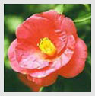
▪ City flower: Designated on March 1. 1970
▪ City tree: Designated on July 1. 1978
The balance of dark green leaves and pink flowers conveys the spirit of the warm hearted citizens. The fresh, brilliant and deep green foliage of the trees symbolizes the youth and ambition of the people of Busan.

(3) City bird – Seagull
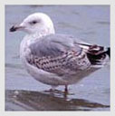
▪ Designated on July 1. 1978
The color of the sea gull, white, represents purity and peace, reflecting the traditional mind of Koreans

(4) Symbol Mark


▪ Designated on March 28. 1995
The upper triangle represents the universe, space and creation, and the lower means the sea and background of Busan. And the two waves represent spreading toward other worlds and the future. The whole image symbolizes balance and vitality.

(5) Mascot " Busan Vision, Busan Vitality, Busan Victory."

▪ Designated on June 14. 1995
Buvi depicts the sun rising to the surface of the sea, the billowy deep, and being born anew. It represents a spiritual image of Busan as the rising sun, and displays the vision and the hope of Busan to make the city an earthly paradise in the 21st Century.

3. Geography
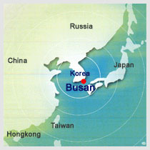
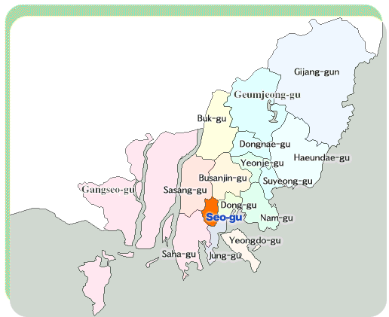
Fig 2. Location of Busan Fig 3. Map of Busan

Geographically, Busan has the Straits of Korea to its South; and, it is adjoined with Yangsan and Gimhae to the North; Ulsan to the East, Jinhae and another part of Gimhae to the West.
Cities that share almost the same latitude with Busan include Gimhae, Masan and Gwangju at home, as well as Los Angeles, Baghdad and Athens abroad. Busan is 8:37 faster than the world standard time.
As for its geopolitical location, the city comes at the Southern tip of a strip that connects Asia, Siberia and Europe. It also serves as the main gateway to the Pacific and to the Atlantic. This location places the city at the center of the international sea transportation.
The east borders with Gijang-gun and Jangan-eup Hyoam-ri, and the west with Gangseo-gu,
Cheonga-dong and Mibaeg-do. The south borders with Saha-gu, Dadae-dong, and Namhyeong-jaedo and the north borders with Gijang-gun, Jangan-eup and Myeongrye-ri.

Table 3. Location of Busan
 | Point | Longitude and Latitude
Eastern end | ▪ Gijang-gun  ▪ Jangan-eup Hyoam-ri | East longitude 129˚ 18' 13"
Western end | ▪ Gangseo-gu  ▪ Cheonga-dong Mibaeg-do | East longitude 128˚ 45' 54"
Southern end | ▪ Saha-gu Dadae-dong Namhyeong-jaedo | North latitude 34˚ 52' 50"
Northern end | ▪ Gijang-gun Jangan-eup Myeongrye-ri | North latitude 35˚ 23' 36"
In Busan City, there are 16 districts, gu and 1 district, gun, which provide administrative services and welfare services on hand to the residents

4. Administration

Table 3. Structure and Administrative Organization (As of June 30, 2005)
City Hall |  |  |  |  | City Council
Office | Bureau | Head Office | Department | Department  (be in charge) | Secretariat | charge | Special Advisory  Committee
2 | 9 | 1 | 5 | 50 | 1 | 2 | 6

City |  |  |  | Management Office | District (Gu,Gun)
Laboratory | Center | Fire Station | Fire Branch | Management Office | Office  Bureau | Department  (be in charge) | HealthService Center | Eup,  Myun,  Dong
2 | 1 | 10 | 53 | 21 | 45 | 250 | 16 | Eup(2)  Myun(3)  Dong(221)

City |  |  |  | District (Gu,Gun)
Main Office | Council | Direct Organ | Department | District (Gu,Gun)
1,848 (11.3%) | 98 (0.6%) | 2,174 (13.3%) | 2,152 (13.2%) | 10,038 (61.6%)
Subtotal : 6,269 (38.4 %)
Total : 16,307
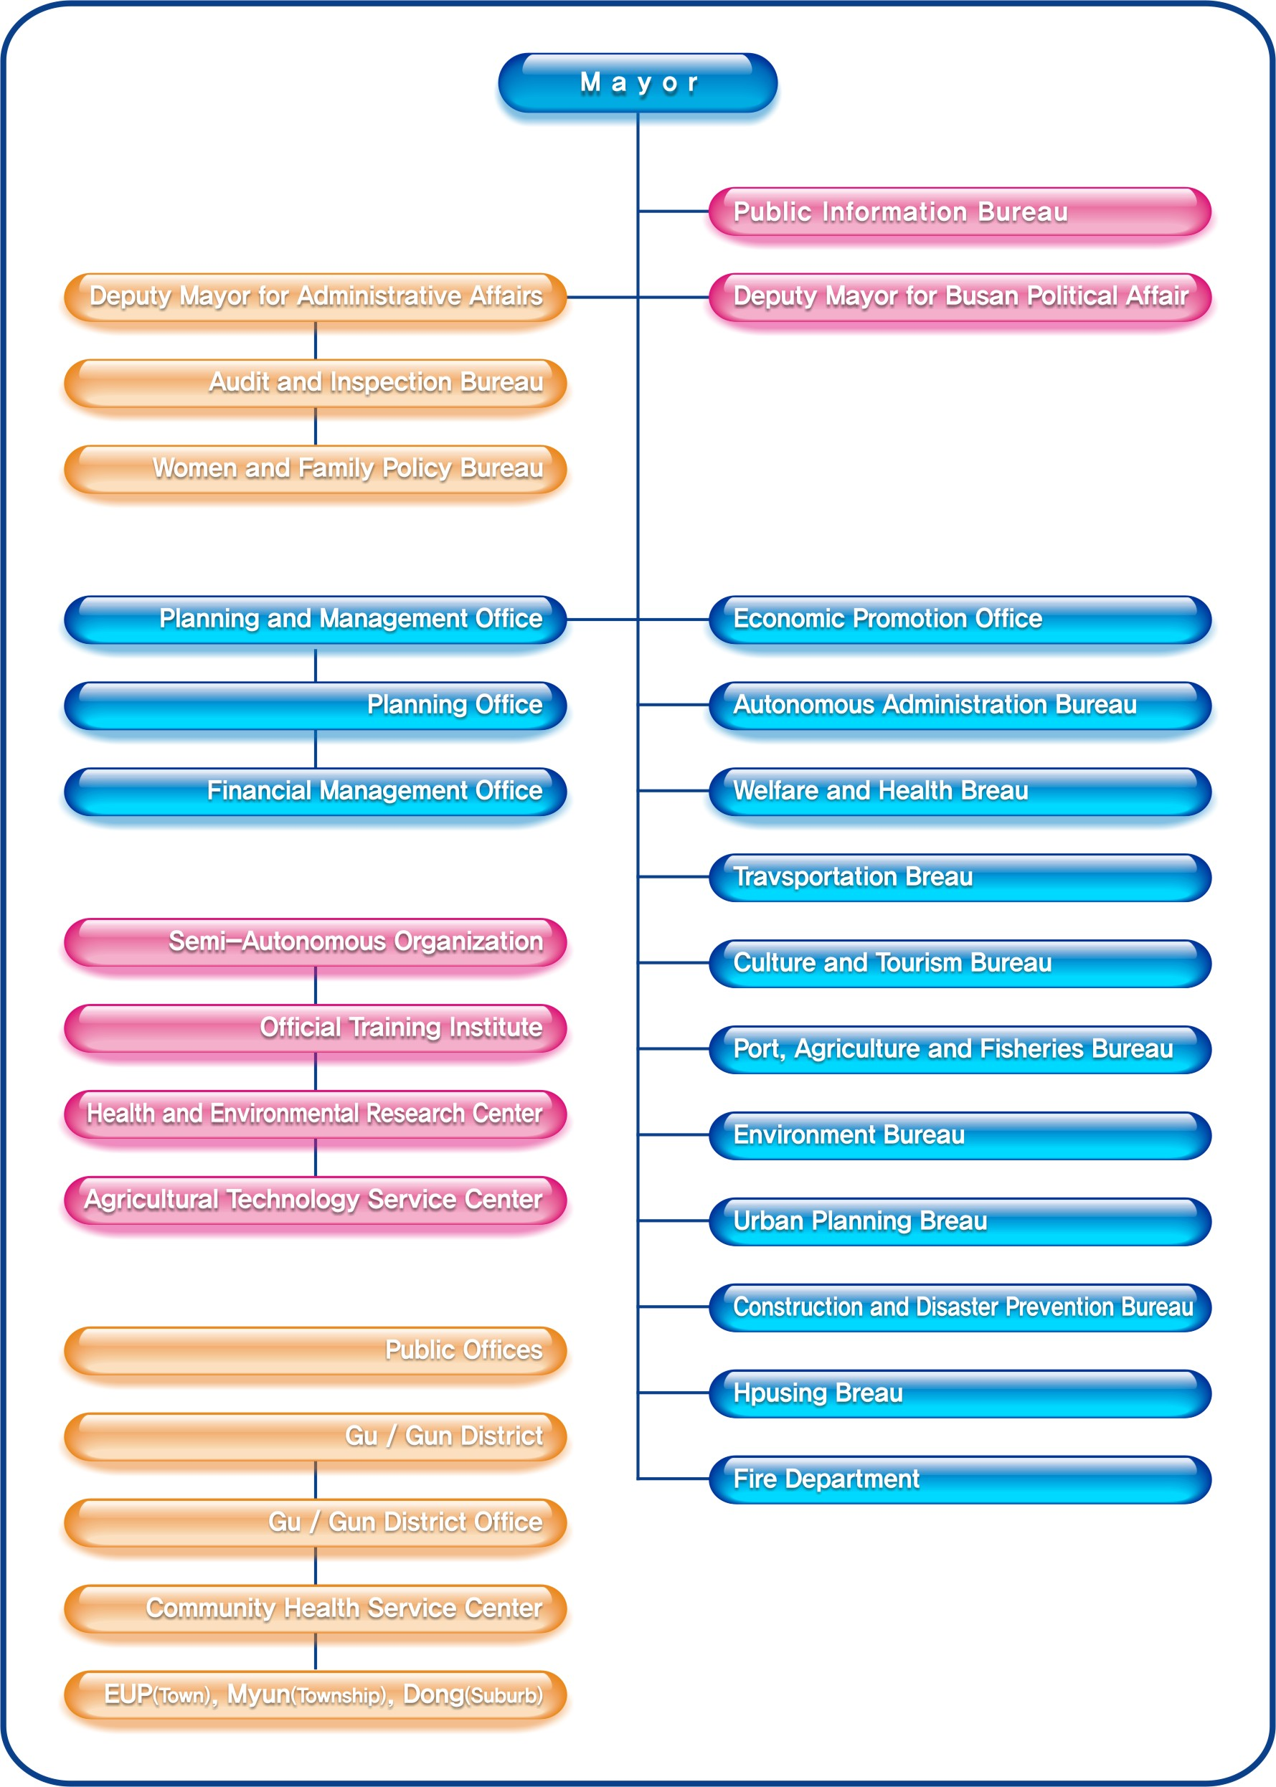
Chart 1. Administrative Organization in Busan City

The Healthy Cities Task Force is not yet established, but will be operated in the following structure.

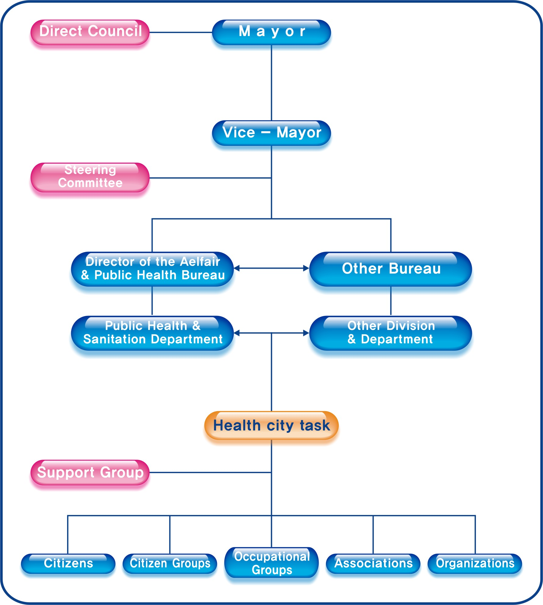
Chart 2. Healthy City Organization

5. Economics
The total budget of Busan for the 2000 fiscal year, including budgets for autonomous Gu (district) and Gun (county), was 4.234 trillion won. This includes general accounts of 2.821 trillion won and special accounts of 1.423 trillion won. The budget for the operation of city headquarters was 3.02 trillion won. The budget for self - governing Gu (district) was 1.16 trillion won and that for autonomous Gun (county) was 500 billion won.

Table 4. Budget by Year (unit : 100 million won)
Classification | Total | General account | Special account
1999 | 55,666 (41,643) | 32,105 (19,975) | 23,561 (21,668)
2000 | 46,194 (33,621) | 30,842 (19,797) | 15,352 (13,825)
2001 | 68,887 (44,462) | 40,888 (25,053) | 27,999 (19,409)
2002 | 67,495 (50,814 | 45,111 (29,943) | 22,384 (20,871)
2003 | 66,587 (47,334) | 49,770 (31,883) | 16,817 (15,451)
2004 | 68,568 (48,732) | 50,729 (33,228) | 17,839 (15,504)
2005 | 64,886 (47,580) | 48,254 (32,497) | 16,632 (15,083)

Table 5. Tax-bearing per one person (unit : 100 million won)
Classification | Nationwide | Busan | Seoul
1999 | 344 | 496 | 310
2000 | 391 | 589 | 364
2001 | 492 | 751 | 420
2002 | 452 | 756 | 443
2003 | 597 | 831 | 515
2004 | 661 | 944 | 568

Table 6. Financial Index (unit : 100 million won)
Classification | Nationwide | Busan | Seoul
1999 | 948 | 575 | 767
2000 | 1,080 | 739 | 891
2001 | 1,282 | 831 | 1,090
2002 | 1,609 | 940 | 1,081
2003 | 1,582 | 1,062 | 1,204
2004 | 1,744 | 1,173 | 1,392
Data source : Busan City Hall homepage http://www.busan.go.kr/

Table 7. Status of Local Tax Collection (unit : 100 million won)
Year | Total | Ordinary Tax
Year | Total | Acquisition Tax | Registration  tax | Inhabitant  tax |  | Tobacco consumption tax |  | Others
1999 | 13,833 | 2,210 | 3,022 | 1,666 |  | 1,616 |  | 3,136
2000 | 14,330 | 2,142 | 2,817 | 1,983 |  | 1,723 |  | 3,415
2001 | 17,951 | 2,601 | 3,73 | 1,936 |  | 1,760 |  | 3,468
2002 | 21,600 | 3,666 | 5,136 | 2,112 |  | 1,770 |  | 3,909
2003 | 22,551 | 3,781 | 5,233 | 2,323 |  | 1,810 |  | 4,345
2004 | 21,830 | 3,090 | 3,966 | 2,433 |  | 2,050 |  | 4,957
Year | Ordinary Tax |  |  |  |  |  |  | Previous  Year
Year | City planning | Fire Service | Local Development |  | Education |  | Workshop Tax | Previous  Year
1999 | 718 | 248 | 669 |  | 0 |  | 192 | 356
2000 | 745 | 62 | 731 |  | 0 |  | 211 | 301
2001 | 763 | 259 | 711 |  | 2,110 |  | 228 | 342
2002 | 798 | 274 | 789 |  | 2,488 |  | 239 | 419
2003 | 851 | 295 | 833 |  | 2,562 |  | 263 | 255
2004 | 952 | 330 | 919 |  | 2,524 |  | 274 | 335
Data source: Busan City Hall homepage http://www.busan.go.kr/

II. Health Profile of Busan

The Busan Health Profile aims at the precise description of the current information about the health of the people and the influential factors. The Busan Health Profile offers precise health information in order to confirm major health issues and related factors of health issues in Busan , set the future goals based on this profile, and secure basic documents to monitor future outcomes of the project.
The main contents of the Busan Health Profile include health status, use of medical service, health behavior and environmental factors related with health. The index of health status include mortality, morbidity of chronic disease and use of outpatient and hospitalization. The health risk behaviors result in the most significant mortality, morbidity, disability and social problems during lifetime. Theses include : behaviors that result in cigarette use; alcohol drinking; dietary behaviors; and physical activity etc. The environmental factors related with health include social and economic status, physical environment, imbalance, physical and social infrastructure.

▪ Method
The public health index survey in Busan used a sample design to produce a representative household sample of 16 gu·gun including 220 dong·eup·myen. The total family member of sample household was surveyed. Face to face survey was conducted for two months from September 2004.

Table 8. Sample size on public health index survey in Busan.
No. of sample district | No. of sample household | Sample household per gu or gun | Sample people(person)
16 | 8,000 | 260 - 760 | Health status 1) | Health behavior 2)
16 | 8,000 | 260 - 760 | 27,200 | 8,000
1) 3.4 person per household
2) Family who is age 20 years and over (1 per 1 household)
The index that couldn’t produce from this survey or produce from the existing data analyzed using secondary data.
1. Population

Since its opening in 1876, the port city of Busan has developed into the hub of trade, commerce and industry. This magnificent development resulted in a major increase in its population, which already reached 200,000 in 1936. A major leap in Busan population came upon the breakout of the Korean War, which resulted in an endless stream of people into the city. As a result, the population of Busan exceeded 1 million by the end of 1955. Another factor that spurred the population increase was the government policy of economic growth. People from urban areas kept streaming into the city for jobs. By the end of 1994, there were approximately 4 million people who called Busan their home. This trend continued until 1995, the year a small decrease in population began. As of December 2005, Busan was home to 3,657,840 people, which constitute about 8.0% of the total population in Korea.

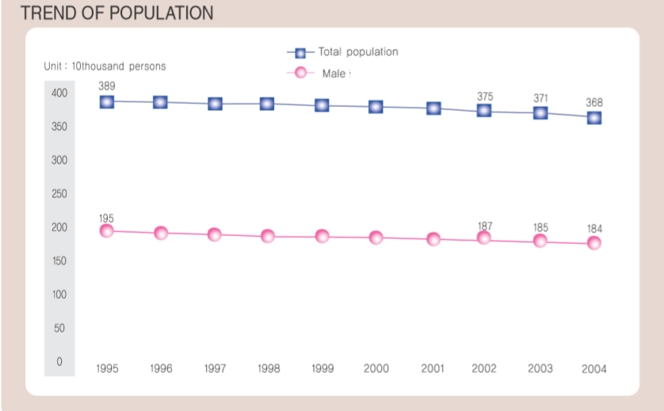
Chart 3. Trend of population in Busan

There is an average of 228,625 people living in each gu(gun). The number of people living by gu(gun) is shown in the following chart. Busanjin-gu provides residence for the most people, 412,055 and Jung-gu with the least of 52,618.

Table 9. Population and area of Administrative units (As of December 31, 2005)
 | Number  of dong | Number of  Household | Population |  |  | Size of  land(km2)
 | Number  of dong | Number of  Household | Total | Male | Female | Size of  land(km2)
Total | 227 | 1,270,612 | 3,657,840 | 1,823,636 | 1,834,204 | 763.46
Jung-gu | 9 | 21,488 | 52,618 | 25,808 | 26,810 | 2.80
Seo-gu | 15 | 52,447 | 140,319 | 69,578 | 70,741 | 13.68
Dong-gu | 17 | 42,136 | 110,758 | 55,263 | 55,495 | 9.77
Yeongdo-gu | 14 | 57,934 | 164,069 | 82,020 | 82,049 | 13.98
Busanjin-gu | 25 | 147,811 | 412,055 | 204,890 | 207,165 | 29.68
Dongnae-gu | 14 | 93,833 | 276,728 | 137,726 | 139,002 | 16.64
Nam-gu | 19 | 105,365 | 303,558 | 151,581 | 151,977 | 26.02
Buk-gu | 13 | 110,915 | 336,483 | 168,189 | 168,294 | 38.30
Haeundae-gu | 18 | 137,424 | 406,280 | 200,193 | 206,087 | 51.44
Saha-gu | 16 | 126,389 | 374,504 | 187,795 | 186,709 | 40.89
Geumjeong-gu | 18 | 91,781 | 266,329 | 131,875 | 134,454 | 65.19
Gangseo-gu | 7 | 21,311 | 55,607 | 29,717 | 25,890 | 179.04
Yeonje-gu | 13 | 75,279 | 218,335 | 108,611 | 109,724 | 12.08
Suyeong-gu | 10 | 62,897 | 179,449 | 87,381 | 92,068 | 10.21
Sasang-gu | 14 | 93,876 | 279,907 | 142,400 | 137,507 | 35.84
Gijang-gun | 5 | 29,726 | 80,841 | 40,609 | 40,232 | 217.90

Data source: Busan City Hall homepage http://www.busan.go.kr/
Gijang-gun : Gijang-eup, Jangan-eup, Ilgwang-myun, Jeonggwan-myun, Cheolma-myun

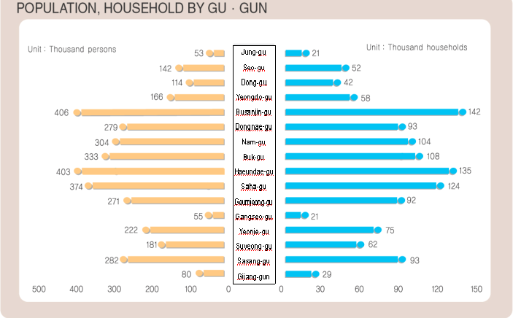
Chart 4. Population, Household by Gu and Gun in Busan
The age group with the most people is ages 25-29, which counts for 8.3% of the total. Children between ages 0-4 and ages 5-9 count 3.9% and 5.6%, respectively. This is lower than the average of Korea, which is 5.0% and 6.7%. However, adolescent between ages 10-14 constitute 6.8%, respectively, which is higher than the average of Korea, which is 7.3%.

Table 10. Population by Age (5-ear age group) Group and Gender
Age | Busan |  |  |  |  | Korea
Age | Total | % | Male | Female | Sex Ratio | % | Sex Ratio
0~4 | 142,926 | 3.9 | 74,377 | 68,549 | 108.50 | 5.0 | 108.42
5~9 | 203,632 | 5.6 | 107,988 | 95,644 | 112.90 | 6.7 | 109.69
10~14 | 247,197 | 6.8 | 133,836 | 113,361 | 118.06 | 7.3 | 113.41
15~19 | 238,806 | 6.6 | 126,362 | 112,444 | 112.38 | 6.4 | 111.17
20~24 | 308,357 | 8.5 | 159,270 | 149,087 | 106.83 | 7.6 | 106.49
25~29 | 300,623 | 8.3 | 154,077 | 146,546 | 105.14 | 8.0 | 10466
30~34 | 291,106 | 8.0 | 147,699 | 143,407 | 102.99 | 9.0 | 103.96
35~39 | 299,536 | 8.2 | 148,673 | 150,863 | 98.55 | 9.1 | 103.77
40~44 | 313,963 | 8.6 | 153,668 | 160,295 | 95.87 | 8.8 | 104.62
45~49 | 340,917 | 9.4 | 166,395 | 174,522 | 95.34 | 8.3 | 102.94
50~54 | 273,233 | 7.5 | 135,008 | 138,225 | 97.67 | 6.1 | 100.61
55~59 | 209,374 | 5.8 | 104,028 | 105,346 | 98.75 | 4.7 | 98.60
60~64 | 165,839 | 4.5 | 81,360 | 84,479 | 96.31 | 4.1 | 90.14
65~69 | 128,197 | 3.5 | 59,076 | 69,121 | 85.47 | 3.5 | 81.35
70~74 | 83,804 | 2.3 | 33,864 | 49,940 | 67.81 | 2.5 | 67.12
75~79 | 50,564 | 1.4 | 16,391 | 34,173 | 47.96 | 1.5 | 52.31
80~84 | 26,729 | 0.7 | 7,520 | 19,209 | 39.15 | 0.9 | 45.89
over 85 | 13,490 | 0.4 | 3,007 | 10,483 | 28.68 | 0.5 | 33.87
Total |  | 100 | 1,812,599 | 1,825,694 | 99.28 | 100 | 100.54
  3,638,293
Data Sources: Korea National Statistical Office www.nso.go.kr

Table 11. Population Trend by Gender (unit: person)
Year | Total | Busan |  |  |  |  | Sex ratio  of Korea1)
Year | Total | Male |  | Female |  | Sex ratio | Sex ratio  of Korea1)
Year | Total | Number | % | Number | % | Sex ratio | Sex ratio  of Korea1)
1980 | 3,159,766 | 1,570,367 | 49.7 | 1,589,399 | 50.3 | 98.8 | 101.8
1985 | 3,514,798 | 1,736,376 | 49.4 | 1,778,422 | 50.6 | 97.6 | 101.7
1990 | 3,798,113 | 1,881,926 | 49.5 | 1,916,187 | 50.5 | 98.2 | 101.3
1995 | 3,892,972 | 1,946,702 | 50.0 | 1,946,270 | 50.0 | 100 | 101.0
2000 | 3,812,392 | 1,905,565 | 50.0 | 1,906,827 | 50.0 | 99.9 | 100.8
2001 | 3,786,033 | 1,891,585 | 50.0 | 1,894,448 | 50.0 | 99.9 | 100.8
2002 | 3,747,369 | 1,871,335 | 50.0 | 1,876,034 | 50.0 | 99.8 | 100.7
2003 | 3,711,268 | 1,853,194 | 50.0 | 1,858,074 | 50.0 | 99.7 | 100.6
2004 | 3,684,153 | 1,838,789 | 49.9 | 1,845,364 | 50.1 | 99.6 | 100.6
2005 | 3,638,293 | 1,812,599 | 49.8 | 1,825,694 | 50.2 | 99.3 | 100.5
Data Sources : Busan Statistical YearBook2005 pp70 ,Korea National Statistical Office

Breaking the population into age groups, 16.3% of the population are between the ages 0-14, 75.4% are between ages 15-64 and those aged over 65 constitute 8.3% of the residents.
As for the population spread by age group of Busan, the age group of 0-14 was 970,753 in 1990, making up 25.57%. It decreased to 593,755 or 16.32% in 2005. The proportion of elderly aged 65 and over increased from 3.35% in 1990 and 6.03% in 2000 to 8.32% in 2005.

Table 12. Population Trend and Household Trend
Year | Busan |  |  |  | Nationwide
Year | Household |  | Population |  | Annual  Growth rate
Year | Number | People per  Household | Number | Annual  Growth rate | Annual  Growth rate
1980 | 689,371 | 4.6 | 3,159,766 | 4.12 | 1.79
1985 | 840,765 | 4.2 | 3,514,798 | 0.56 | 1.83
1990 | 994,033 | 3.8 | 3,798,113 | -1.53 | 1.73
1995 | 1,132,360 | 3.4 | 3,892,972 | 1.20 | 1.51
2000 | 1,199,804 | 3.2 | 3,812,392 | -0.49 | 1.35
2001 | 1,210,902 | 3.1 | 3,786,033 | -0.69 | 1.33
2002 | 1,219,902 | 3.1 | 3,747,369 | -1.02 | 1.30
2003 | 1,236,262 | 3.0 | 3,711,268 | -0.96 | 1.28
2004 | 1,251,069 | 2.9 | 3,684,153 | -0.73 | 1.27
2005 | 1,270,612 | 2.8 | 3,638,293 | -1.24 | 1.25
Data Sources : Busan Statistical YearBook2005, p70
Korea National Statistical Office www.nso.go.kr

Unlike the usual larger number of males to females, the number of female was larger in Busan . The female rate was 50.3% in 1980, 50.5% in 1990, 50.0% in 2000, and 50.2% in 2005. The sex ratio of Korea was 101.8 in 1980 and 100.5 in 2005. It has shown some change but has never fallen below 100. However, the sex ratio of Busan has continuously shown the figures below 100

Table 13. Percentage of children and elderly by year (unit : person)
Age Group |  | 1990 |  | 1995 |  | 2000 |  | 2005
 |  | Number | % | Number | % | Number | % | Number | %
0-14 | 0~4 | 268,198 | 7.07 | 263,849 | 6.79 | 209,980 | 5.53 | 142,926 | 3.93
0-14 | 5~14 | 702,555 | 18.50 | 582,162 | 14.99 | 493,547 | 13.00 | 450,829 | 12.39
0-14 | total | 970,753 | 25.57 | 846,011 | 21.78 | 703,527 | 18.53 | 593,755 | 16.32
15-64 | 15~24 | 800,870 | 21.10 | 757,289 | 19.50 | 674,911 | 17.78 | 547,163 | 15.04
15-64 | 25~44 | 1,324,956 | 34.90 | 1,400,208 | 36.05 | 1,348,913 | 35.53 | 1,205,228 | 33.13
15-64 | 45~64 | 572,181 | 15.07 | 703,433 | 18.11 | 840,080 | 22.13 | 989,363 | 27.20
15-64 | total | 2,698,007 | 71.08 | 2,860,930 | 73.66 | 2,863,904 | 75.44 | 2,741,754 | 75.36
over 65 | 65~74 | 92,126 | 2.43 | 125,887 | 3.24 | 161,489 | 4.25 | 212,001 | 5.83
over 65 | 75~84 | 30,414 | 0.80 | 42,844 | 1.10 | 57,157 | 1.50 | 77,293 | 2.12
over 65 | over 85 | 4,592 | 0.12 | 8,208 | 0.21 | 10,429 | 0.27 | 13,490 | 0.37
over 65 | total | 127,132 | 3.35 | 176,939 | 4.56 | 229,075 | 6.03 | 302,784 | 8.32
Grand Total |  | 3,795,892 | 100 | 3,883,880 | 100 | 3,796,506 | 100 | 3,638,293 | 100
Data Sources : Busan Statistical YearBook2005 pp84~85, Korea National Statistical Office

2. Health status

(1) Vital Statistics
The birth number shows a gradual increase since 1995. But the death number is slowly on the rise recently.
A total of 19,898 couples got married and 11,334 couples got divorced in 2004 Marriages and divorce number shows a gradual increase since 1995.

Table 14. Vital statistics in Busan city 2004 (unit : person)
Year | Birth | Death | Marriage(Couple) | Divorce(Couple)
1995 | 52,507 | 18,185 | 25,495 | 9,666
2000 | 40 877 | 18,178 | 23,343 | 10,129
2001 | 35 480 | 18,283 | 21,825 | 10,489
2002 | 30 472 | 18,539 | 20,916 | 12,065
2003 | 29 838 | 18,396 | 20,027 | 14,120
2004 | 27 989 | 18,594 | 19,898 | 11,334
Data Source : * :Busan Statistical YearBook2005, p84~85

- Death

The crude death rate of Busan increased from 4.3/1,000 in 1990 and 4.8/1000 in 2000 to 5.1/1000 in 2004. However Korea’s crude death rate decreased from 1990 to 2004. The crude death rate of male is higher than that of female from 2000 to 2004.

Table 15. Trend of crude death rate by year * (unit :person, Crude death rate: per 1000person )
Year | Busan |  |  |  |  |  | Korea
Year | No. of Death |  |  | Crude death rate* |  |  | Crude death rate*
Year | Total | Male | Female | Total | Male | Female | Crude death rate*
1990 | 15,038 | · | · | 4.3 | · | · | 5.8
1995 | 16,833 | · | · | 4.4 | · | · | 5.4
2000 | 18,178 | 10,009 | 8,169 | 4.8 | 5.3 | 4.3 | 5.2
2001 | 18,283 | 10,194 | 8,089 | 4.8 | 5.4 | 4.3 | 5.1
2002 | 18,539 | 10,160 | 8,379 | 4.9 | 5.4 | 4.7 | 5.1
2003 | 18,396 | 10,286 | 8,110 | 5.0 | 5.6 | 4.4 | 5.1
2004 | 18,594 | 10,457 | 8,137 | 5.1 | 5.7 | 4.4 | 5.1
Data Sources: Korea National Statistical Office (2005)
2005 Annual Report on Live Births and Deaths Statistics. KNSO :

Based on the 2004 Annual Report on the Cause of Death Statistics, age-specific death rates were calculated. The age-specific death rate of 10-19 was the lowest at 23.18/100,000 while that of over 70 was the highest of 5,704.40. The death rate was 65.32 in 0-9, 76.87 in 20-39, 386.54 in 40-59, and 1,374.67 in 60-69.

Table 16. Age-specific death rate, 2004 (unit: per 100,000)
Age group | No. of Death* | No. of Mid-Year Population** | Death Rate
0-9 | 249 | 381,173 | 65.32
10-19 | 115 | 496,214 | 23.18
20-39 | 956 | 1,193,562 | 76.87
40-59 | 4,299 | 1,112,171 | 386.54
60-69 | 3,952 | 287,486 | 1,374.67
over 70 | 9,023 | 158,176 | 5,704.40
Total | 18,594 | 3,678,895 | 505.42
Data Source: *Busan Statistical YearBook2005, p84~85.
Korea National Statistical Office www.nso.go.kr
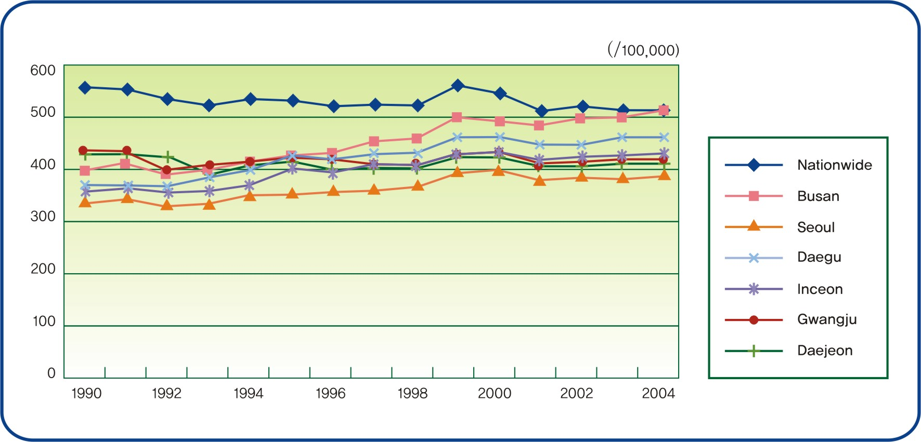
Chart 5. Trend of Crude Death Rate by Cites

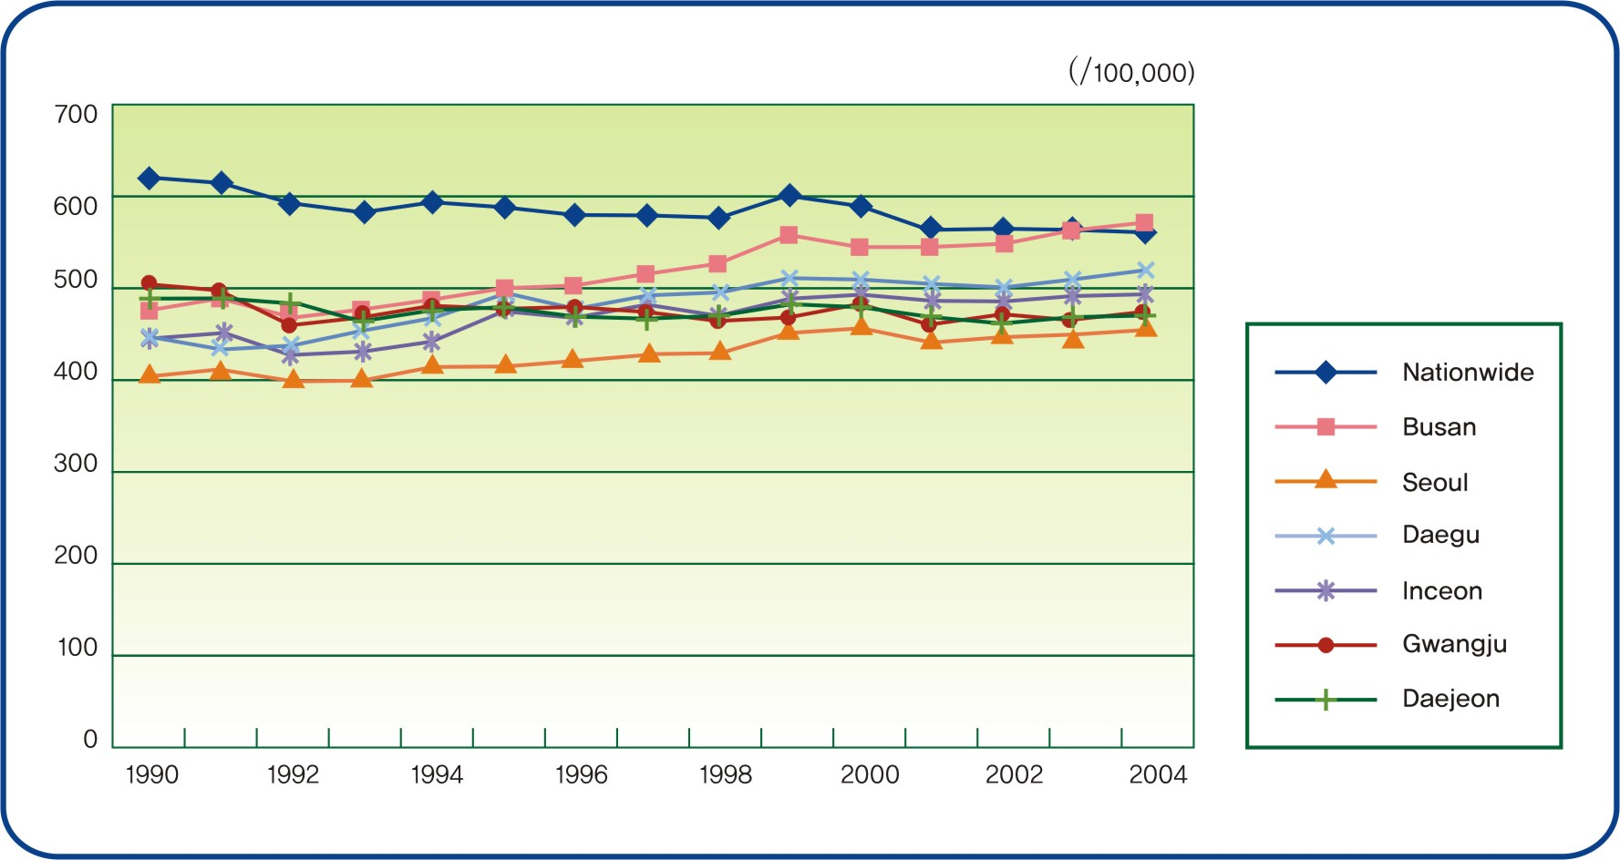
Chart 6. Trend of Crude Death Rate in man by cites

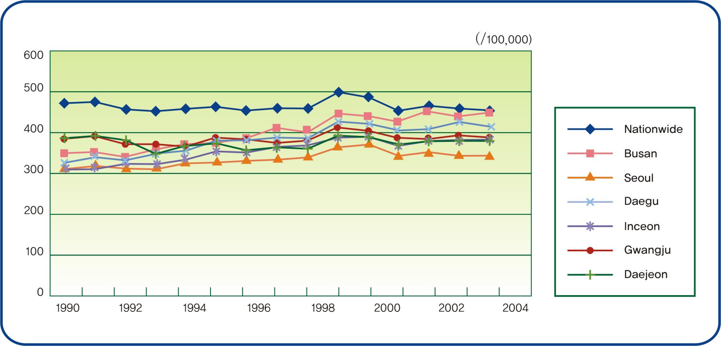
Chart 7. Trend of Crude Death Rate in female by cites

Standardized mortality rate of 2004, based on the assumption that the age distribution of cities are identical, is not only the highest among the major 6 cities regardless of gender but also rather shows an increasing tendency for the past 15 years.
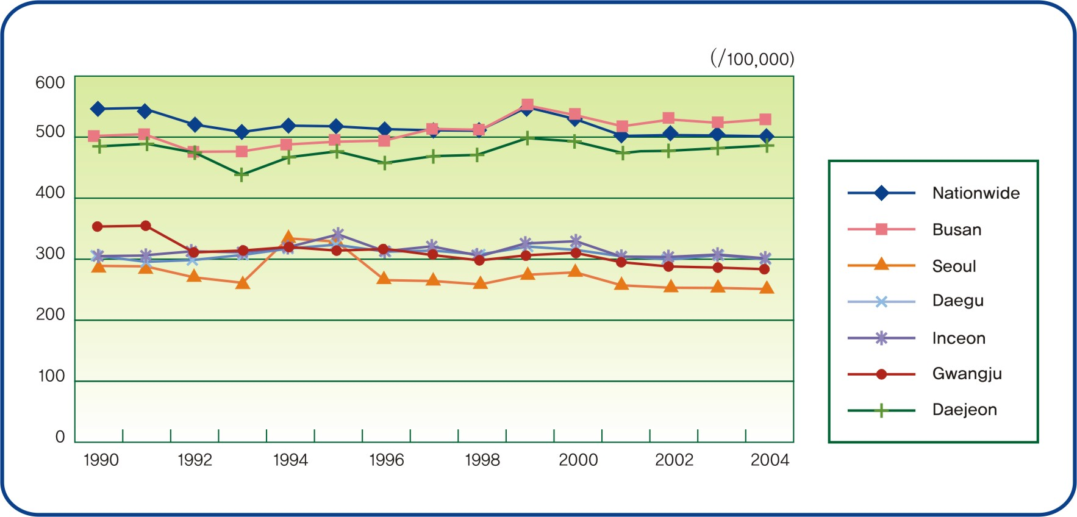
Chart 8. Standardized Mortality Ratio by cities
The annual mortality rate per cause of death was shown in Table 17. Busan had the highest death rate for neoplasm of 142.7/100,000, followed by the diseases of the circulatory system at 141.9, the external cause of mortality diseases at 60.3, symptoms, signs and abnormal clinical and laboratory findings, NEC at 26.4, and the diseases of the respiratory system at 24.5. Meanwhile, the death rates by neoplasm and diseases of the circulatory system were higher than those of the national data while the death rates by external causes of mortality was lower. In addition, the death rates by the diseases of the digestive system and endocrine, nutritional and metabolic diseases were higher.

Table 17. Cause of death- Busan and Korea, 2004 (unit: person, %, rate per 100,000)
Cause of Death | Busan |  |  |  | Korea
Cause of Death | Rank | No | % | Mortality rate | Rank | No | % | Mortality rate
Neoplasm | 1 | 5,248 | 28.2 | 142.7 | 1 | 65,505 | 26.7 | 135.1
Diseases of the circulatory system | 2 | 5,220 | 28.0 | 141.9 | 2 | 58,382 | 23.8 | 120.4
External causes of mortality | 3 | 2,231 | 12.0 | 60.6 | 3 | 30,567 | 12.4 | 63.0
Symptoms, signs and abnormal clinical  and laboratory findings, NEC | 6 | 972 | 5.2 | 26.4 | 4 | 29,990 | 12.2 | 61.9
Diseases of the respiratory system | 7 | 902 | 4.9 | 24.5 | 5 | 14,261 | 5.8 | 29.4
Endocrine, nutritional and metabolic diseases | 5 | 1,027 | 5.5 | 27.9 | 6 | 12,424 | 5.0 | 25.6
Diseases of the digestive system | 4 | 1,072 | 5.8 | 29.1 | 7 | 12,124 | 4.9 | 25.0
mental and behavioral disorders | 9 | 437 | 2.4 | 11.9 | 9 | 4,796 | 2.0 | 9.9
Certain infectious and parasitic disease | 8 | 514 | 2.8 | 14.0 | 8 | 5,192 | 2.1 | 10.7
Diseases of the nervous system | 11 | 309 | 1.7 | 8.4 | 10 | 4,143 | 1.7 | 8.5
Disease of the genitourinary system | 10 | 320 | 1.7 | 8.7 | 11 | 3,027 | 1.2 | 6.2
Diseases of the musculoskeletal system  and connective tissue | 12 | 99 | 0.5 | 2.7 | 12 | 1,547 | 0.6 | 3.2
Congenital malformations, deformations  & chromosomal abnormalities | 14 | 72 | 0.4 | 2.0 | 15 | 734 | 0.3 | 1.5
Certain conditions originating in the  perinatal period | 13 | 93 | 0.5 | 2.5 | 13 | 1,197 | 0.5 | 2.5
Diseases of the skin and subcutaneous tissue | 17 | 17 | 0.1 | 0.5 | 17 | 392 | 0.2 | 0.8
Cause unknown | 16 | 20 | 0.1 | 0.5 | 14 | 985 | 0.4 | 2.0
Diseases of the blood and blood-forming  organs and the immune mechanism | 15 | 34 | 0.2 | 0.9 | 16 | 445 | 0.2 | 0.9
Pregnancy, childbirth and the puerperium | 18 | 7 | 0 | 0.2 | 18 | 59 | 0 | 0.1
Diseases of the ear and mastoid process | 20 | 0 | 0 | 0 | 19 | 1 | 0 | 0
Diseases of the eye and adnexa | 20 | 0 | 0 | 0 | 20 | 0 | 0 | 0
Total |  | 18,594 | 100 | 505.4 |  | 245,771 | 100 | 506.9
Data Source : Korea National Statistical Office, www.nso.go.kr

Table 18. Mortality rate by sex and cause of death- Busan and Korea, 2004 (unit: per 100,000 )
Cause of Death | Busan |  |  |  | Korea
Cause of Death | Male |  | Female |  | Male |  | Female
Cause of Death | Rank | Mortality rate | Rank | Mortality rate | Rank | Mortality rate | Rank | Mortality rate
Neoplasm | 1 | 181.6 | 2 | 103.9 | 1 | 171.5 | 2 | 98.5
Diseases of the circulatory system | 2 | 138.4 | 1 | 145.3 | 2 | 115.4 | 1 | 125.5
External causes of mortality | 3 | 87.6 | 4 | 33.9 | 3 | 86.8 | 4 | 39.1
Diseases of the digestive system | 4 | 43.8 | 8 | 14.5 | 5 | 37.0 | 7 | 12.9
Symtoms, signs and abnormal clinical and laboratory findings, NEC | 8 | 13.2 | 3 | 39.6 | 4 | 42.9 | 3 | 80.9
Diseases of the respiratory system | 5 | 28.5 | 6 | 20.6 | 6 | 35.7 | 6 | 23.1
Endocrine, nutritional and metabolic diseases | 6 | 26.9 | 5 | 28.9 | 7 | 25.2 | 5 | 26.0
Certain infectious and parasitic disease | 7 | 18.3 | 9 | 9.7 | 8 | 13.9 | 10 | 7.5
mental and behavioral disorders | 11 | 6.5 | 7 | 17.3 | 9 | 8.1 | 8 | 11.7
Diseases of the nervous system | 10 | 8.0 | 11 | 8.8 | 10 | 8.0 | 9 | 9.1
Disease of the genitourinary system | 9 | 8.0 | 10 | 9.3 | 11 | 6.3 | 11 | 6.2
Diseases of the musculoskeletal system and connective tissue | 14 | 2.0 | 12 | 3.4 | 14 | 1.6 | 12 | 4.8
Cause unknown | 16 | 0.7 | 17 | 0.4 | 13 | 2.2 | 14 | 1.8
Congenital malformations, deformations & chromosomal abnormalities | 13 | 2.3 | 14 | 1.6 | 15 | 1.5 | 15 | 1.5
Certain conditions originating in the perinatal period | 12 | 2.8 | 13 | 2.3 | 12 | 2.7 | 13 | 2.2
Diseases of the skin and subcutaneous tissue | 17 | 0.2 | 15 | 0.8 | 17 | 1.1 | 16 | 1.1
Diseases of the ear and mastoid process | 20 | 0 | 20 | 0 | 20 | 0 | 19 | 0
Diseases of the eye and adnexa | 20 | 0 | 20 | 0 | 20 | 0 | 20 | 0
Diseases of the blood and blood-forming organs and the immune mechanism | 15 | 1.1 | 16 | 0.7 | 16 | 0.9 | 17 | 0.9
Pregnancy, childbirth and the puerperium | 20 |  | 18 | 0.4 | 20 | 0 | 18 | 0.4
Total |  | 569.7 |  | 441.4 |  | 560.3 |  | 453.2
Data Source: Korea National Statistical Office www.nso.go.kr.

The major causes of death by age were different. The most common cause of death in the age group of 1-9 is car accidents followed by Congenital malformations, Deformations & chromosomal abnormalities, drowning, falls, External causes of mortality and murder. For the 10-19, the highest mortality rate was by car accidents followed by disease of the nervous system suicide, and leukemia. As for the 20-39 age group the most common cause of death was suicide, followed by car accidents, and the external causes of mortality, liver disease, and ischemic heart disease. In the case of the 40-59 age group the highest death rate was by liver disease followed by colon rectal cancer, suicide, cerebrovascular disease, and ischemic heart disease. . As for the 60-69 age group the most common cause of death was cerebrovascular disease followed by, ischemic heart disease, bronchial cancer, liver cholangio-cancer and diabetes mellitus. In the age group over 70, the order of cause of death was showed as cerebrovascular disease, ischemic heart disease, diabetes, and chronic lower respiratory disease.

Table 19. Five leading causes of death by age, 2004. (unit: person )
Age  Group | No of Total | Rank 1 | No | Rank 2 | No | Rank 3 | No | Rank 4 | No | Rank 5 | No
1-9 | 75 | Traffic accident | 13 | Congenital malformations,  Deformations & chromoso  -mal abnormalities | 11 | Fall accident | 9 | External causes of  Mortality | 8 | murder | 7
10-19 | 115 | Traffic accident | 25 | Disease of the  nervous System | 13 | Suicide | 13 | Malignant neoplasm | 11 | leukemia | 10
20-39 | 956 | Suicide | 245 | Traffic accident | 83 | External cases of mortality | 62 | Liver disease | 55 | ischemic heart disease | 44
40-59 | 4,299 | Liver disease | 476 | Colon,rectal cancer | 472 | suicide | 402 | Cerlebrovascular disease | 396 | Ischemic heart disease | 323
60-69 | 3,952 | Cerebrovascular disease | 569 | Ischemic heart  disease | 348 | Bronchoial  cancer | 331 | Liver, cholangio  cancer | 304 | Diabetes  mellitus | 275
70-79 | 4,723 | Cerebrovascular disease | 938 | Ischemic heart  disease | 508 | Diabetes  mellitus | 352 | Bronchoial  cancer | 306 | Stomach  cancer | 248
over 80 | 4300 | Cerebrovascular disease | 810 | Ischemic heart  disease | 366 | .mental & behavioral  disorders | 254 | Chronic lower  respiratory | 236 | Diabetes  mellitus | 201
Data Source : Korea National Statistical Office www.nso.go.kr

The number of infant deaths in Busan was 174 and that of live births was 27,985 in 2004. The infant mortality rate of 6.4/1,000 was higher than 5.3/1,000 in the national data. As for the infant mortality causes in Busan , certain conditions originating in the perinatal period were 93 cases, making up 3.32/1,000. It was higher than 2.87/1,000 in the national data. Meanwhile, there were 46 deaths from congenital malformations, deformations & chromosomal abnormalities (1.64/1,000), larger than proportion of the same cause of death of the national data. The third cause was symptoms, signs and abnormal clinical and laboratory findings, NEC

Table 20. Causes of Infant Death, 2004. (unit: per live birth 1,000)
Rank | Busan |  |  | Korea
Rank | Cause of Death | N | % | Cause of Death | N | %
1 | Certain conditions originating in the perinatal period | 93 | 3.32 | Certain conditions originating  in the perinatal period | 1,195 | 2.87
2 | Congenital malformations, deformations & chromosomal abnormalities | 46 | 1.64 | Congenital malformations, deformations & chromosomal abnormalities | 456 | 1.09
3 | Symtoms, signs and abnormal clinical and laboratory findings, NEC | 10 | 0.36 | Symtoms, signs and abnormal clinical and laboratory findings, NEC | 197 | 0.47
4 | External causes of mortality | 7 | 0.25 | External causes of mortality | 124 | 0.30
5 | Disease of the nervous system | 5 | 0.18 | Disease of the nervous system | 54 | 0.13
6 | Neoplasm | 3 | 0.14 | Endocrine, nutritional and  metabolic diseases | 33 | 0.08
6 | Diseases of the respiratory system | 3 | 0.14 | Neoplasm | 28 | 0.07
8 | Diseases of the circulatory system | 2 | 0.07 | Diseases of the circulatory system | 22 | 0.05
8 | Case unknown | 2 | 0.07 | Case unknown | 21 | 0.05
10 | Endocrine, nutritional and metabolic diseases | 1 | 0.04 | Certain infectious and parasitic disease | 17 | 0.04
10 | Diseases of the digestive system | 1 | 0.04 | Diseases of the blood and blood-forming organs and the immune mechanism | 13 | 0.03
10 | Certain infectious and parasitic disease | 1 | 0.04 | Diseases of the digestive system | 12 | 0.02
 |  |  |  | Disease of the genitourinary system | 1 | 0.00
Data Source: Korea National Statistical Office www.nso.go.kr
National Statistical Office(2005).
2004 Annual Report on The Cause of Death Statistics. NSO, p.44-59 & p.372-379.
National Statistical Office(2005).
2004 Annual Report on Live Births & Deaths Statistics. NSO, p.40 & p.116

The ten leading causes of death were shown in Table 13. The cerebrovascular disease was the most common cause of death (74.8 per 100,000 people), followed by ischemic heart disease, malignant neoplasm of liver, Intentional Self-harm, malignant neoplasm of trachea & lung, diabetes mellitus, Symptoms, signs and abnormal clinical and laboratory findings, NEC, malignant neoplasm of the stomach, liver disease, others malignant neoplasm, and chronic lower respiratory system.
Table 21. Ten leading causes of death, 2004. (unit : per 100,000)
 | Busan |  |  | Nationwide
Rank | Cause of Death | N | Death  Rate | Cause of Death | N | Death  Rate
1 | Cerebrovascular Dis. | 2,753 | 74.8 | Cerebrovascular Dis. | 34,091 | 70.3
2 | Ischemic Hearth Dis. | 1,591 | 43.2 |  | 29,990 | 61.9
3 | Malignant Neoplasm of Liver | 1,054 | 28.6 | Malignant Neoplasm of Trachea & Lung | 13,325 | 27.5
4 | Intentional Self-harm | 988 | 26.9 | Ischemic Hearth Dis | 12,760 | 26.3
5 | Malignant Neoplasm of Trachea & Lung | 986 | 26.8 | Diabetes Mellitus | 11,768 | 24.3
6 | Diabetes Mellitus | 980 | 26.6 | Intentional Self-harm | 11,523 | 25.2
7 | Symtoms, signs and abnormal clinical and laboratory findings, NEC | 972 | 26.4 | Malignant Neoplasm of Stomach | 11,255 | 23.2
8 | Malignant Neoplasm of Stomach | 867 | 23.6 | Malignant Neoplasm of Liver | 10,962 | 22.6
9 | Dis. of Liver | 847 | 23.0 | Dis. of Liver | 9,272 | 19.1
10 | Others Malignant Neoplasm | 582 | 15.8 | Chronic lower Respiratory Dis | 8,378 | 17.3
11 | Chronic lower Respiratory Dis | 563 | 15.3 | Traffic accident | 8,333 | 17.2
Total |  | 12,183 | 331.0 |  | 161,657 | 334.9
Data: Source: Korea National Statistical Office www.nso.go.kr

Ischemic heart disease of Busan had the second highest death rate of 43.2 compared with the third highest in the national data of 26.3. The death rate by malignant neoplasm of liver also shows a higher rate of 28.6 than that of 22.6 in the national data. The death rate by suicide in Busan of 26.9 was the third while that in the national data of 23.8 was the seventh. But, the death rate by Malignant Neoplasm of Trachea & Lung of 26.8 was lower than that of 27.5 in the national data.

2) Birth
The live birth rate of Busan decreased from 14.7 in 1990, 13.6 in 1995, and 10.7 in 2000 to 6.5 in 2005, showing a drop, compared with the national data presented here The live birth rate in Korea decreased from 15.4 in 1990 and 16 in 1996 to 13.4 in 2000 and 9.0 in 2005. The birth rate on Busan was lower than that of Korea.

Table 22. Live Birth Rate by Year (unit: per 1,000)
Year | Busan |  | Crude Birth Rate  of Nationwide
Year | No. of Live Birth | Crude Birth Rate | Crude Birth Rate  of Nationwide
1990 | 56,023 | 14.7 | 15.4
1995 | 52,507 | 13.6 | 16.0
2000 | 40,877 | 10.7 | 13.4
2001 | 35,480 | 9.4 | 11.6
2002 | 30,472 | 8.1 | 10.3
2003 | 29,838 | 8.0 | 10.2
2004 | 27,989 | 7.6 | 9.8
2005 | 23,877 | 6.5 | 9.0
Data Source : Korea National Statistical Office www.nso.go.kr

The low birth weight infant was defined as an infant born with the weight of less than 2500g. The rate of low birth weight infants less than 2.5 kg on Busan increased from 3.0/1,000 in 1995 to 3.7 in 2000 and 4.8 in 2004.

Table 23. Rate of Low Birth Weight Infant (less than 2.5kg) (unit : per 1,000)
Year | Busan |  |  | Korea
Year | No. of LBW | No. of Live  Birth | Rate of  LBW Infant | No. of LBW | No. of Live  Birth | Rate of  LBW Infant
1995 | 1,582 | 52,507 | 3.0 | 21,538 | 716,993 | 3.0
2000 | 1,502 | 40,877 | 3.7 | 24,146 | 636,780 | 3.8
2001 | 1,507 | 35,480 | 4.2 | 23,500 | 554,854 | 4.2
2002 | 1,306 | 30,472 | 4.3 | 20,874 | 492,045 | 4.2
2003 | 1,493 | 29,838 | 5.0 | 21,257 | 432,423 | 4.9
2004 | 1,349 | 27,989 | 4.8 | 22,911 | 472,705 | 4.8
Data Source: National Statistical Office, Live Births and Deaths Census http://kosis.nso.go.kr/

(2) Life expectancy and disability adjusted life expectancy
▪ Busan citizens in 2002-2003 year life expectancy showed an average of 76.7 years. (73.15 years in male and 80.years in female) The female lives 6.8years more than the male.

Table 24. Life expectancy by age in Busan (unit: year)
Age group | Busan |  |  | Nationwide
Age group | Total | Male | Female | Total | Male | Female
0 | 76.72 | 73.15 | 80.02 | 77.00 | 73.38 | 80.44
1∼4 | 76.16 | 72.66 | 79.36 | 76.44 | 72.84 | 79.86
5∼9 | 72.27 | 68.77 | 75.47 | 72.56 | 68.96 | 75.97
10∼14 | 67.33 | 63.83 | 70.53 | 67.64 | 64.04 | 71.04
15∼19 | 62.37 | 58.87 | 65.57 | 62.7 | 59.1 | 66.09
20∼24 | 57.47 | 53.98 | 60.65 | 57.81 | 54.24 | 61.17
25∼29 | 52.60 | 49.14 | 55.74 | 52.96 | 49.42 | 56.28
30∼34 | 47.76 | 44.34 | 50.85 | 48.12 | 44.62 | 51.39
35∼39 | 37.96 | 34.62 | 40.97 | 43.32 | 39.87 | 46.52
40∼44 | 38.22 | 34.95 | 41.12 | 38.59 | 35.23 | 41.69
45∼49 | 33.60 | 30.47 | 36.35 | 33.99 | 30.75 | 36.91
50∼54 | 29.12 | 26.17 | 31.64 | 29.52 | 26.46 | 32.2
55∼59 | 24.79 | 22.09 | 26.98 | 25.2 | 22.36 | 27.57
60∼64 | 20.63 | 18.19 | 22.46 | 21.03 | 18.47 | 23.06
65∼69 | 16.70 | 14.57 | 18.11 | 17.11 | 14.88 | 18.72
70∼74 | 13.03 | 11.25 | 14.04 | 13.48 | 11.64 | 14.66
75∼79 | 9.91 | 8.49 | 10.58 | 10.24 | 8.86 | 11.05
80∼84 | 7.37 | 6.36 | 7.77 | 7.59 | 6.63 | 8.08
Over 85 | 5.49 | 4.73 | 5.72 | 5.52 | 4.9 | 5.82
Data source: Busan Health Status and Medical Utilization Survey, 2004

▪ Busan citizens' predicted life span at birth based on subjective health awareness shows a 62.69yr, male 62.21 and female 63.21 with the female having a margin of 1yr. However, the margin between Busan citizens' average life span and their health span was 14yrs with the male having an 11yr and the female having a 17yr difference.

Table 25. Disability adjusted life expectancy (unit: year )
Age group | Total | Male | Female | Age group | Total | Male | Female
0 | 62.69 | 62.21 | 63.21 | 45∼49 | 22.49 | 22.14 | 22.76
1∼4 | 62.11 | 61.71 | 62.54 | 50∼54 | 18.65 | 18.40 | 18.84
5∼9 | 58.43 | 58.06 | 58.83 | 55∼59 | 15.05 | 14.98 | 15.06
10∼14 | 53.77 | 53.42 | 54.15 | 60∼64 | 11.77 | 11.63 | 11.77
15∼19 | 49.09 | 48.77 | 49.45 | 65∼69 | 9.08 | 8.91 | 9.09
20∼24 | 44.46 | 44.17 | 44.78 | 70∼74 | 6.72 | 6.30 | 6.89
25∼29 | 39.93 | 39.57 | 40.28 | 75∼79 | 5.11 | 4.71 | 5.27
30∼34 | 35.35 | 34.88 | 35.77 | 80∼84 | 3.63 | 3.23 | 3.78
35∼39 | 26.44 | 25.96 | 26.86 | Over 85 | 2.65 | 2.36 | 2.72
40∼44 | 26.62 | 26.21 | 26.96
Data source : Busan Health Status and Medical Utilization Survey, 2004

(3) Morbidity

1) Chronic Disease
The 2001 Seoul city survey was compared with the 2001 Public health survey in the research of significant chronic illness self-recognition rate. Though, due to the fact of this research being conducted in 2004 a direct comparison with the 2001 survey might be vulnerable to errors, it was considered to be meaningful in that it provides as reference regarding Busan citizens' main chronic illnesses.
Among the major 6 cancers gastric cancer, liver cancer, breast cancer(female) and uterine cancer(female) showed higher than both Seoul city and nationwide. While lung cancer and colon cancer showed higher than Seoul city it appeared lower than the overall country. Arthritis and chronic nephrotic syndrome showed a similar distribution with Seoul city but showed only half compared to that of the nationwide rate. Diabetes showed an index of 28.55 per every 1,000 population, being higher than both Seoul city and nationwide. This is assumed to reflect the sharp increase in recent diabetes morbidity. Thyroid disease was lower than both the Seoul city and nationwide. Hypertension showed an index of 62.41 per every 1,000 population, being higher than both Seoul city and the overall country. This likewise reflects the sharp increase in recent hypertension morbidity as shown in diabetes. Cerebrovascular disease including ischemic heart disease are also all higher than both Seoul city and nationwide. Pulmonary tuberculosis showed an index of 1.55 per every 1,000 population which being lower than both Seoul city(1.68) and nationwide(2.11). Asthma has an index of 5.02 per every 1,000 population. This index is just but a third of what the overall country shows but it is only slightly lower than Seoul city's 5.84. Depression shows a 3.14 per every 1,000 population which is almost the same as the nationwide rate of 3.23.
Chronic nephrotic syndrome has a 2.28 per every 1,000 population which is a twofold of the nationwide rate of 1.05.

Table 26. Perceived Prevalence rate of the chronic diseases (unit: per 1,000)
Chronic disease | Busan | Seoul* | Nationwide**
Stomach cancer | 1.54 | 0.99 | 1.29
Liver cancer | 0.64 | 0.30 | 0.26
Lung cancer | 0.29 | 0.25 | 0.35
Colon cancer | 0.65 | 0.45 | 0.67
Breast cancer(female) | 1.50 | 1.49 | 0.86
Uterus cervical cancer(female) | 2.02 | 1.67 | 1.47
The other cancer | 1.05 | 1.27 | 1.32
Arthritis | 35.98 | 37.38 | 77.74
Chronic back pain | 15.78 | 16.50 | 48.62
Diabetes mellitus | 28.55 | 22.70 | 25.85
Thyroid disease | 4.81 | 5.14 | 6.93
Hypertension | 62.41 | 47.22 | 58.98
Cerebrovascular disease | 9.40 | 5.86 | 8.61
Angina and Ischemic heart disease | 9.13 | 3.75 | 6.54
Pulmonary tuberculosis | 1.55 | 1.68 | 2.11
Asthma | 5.02 | 5.84 | 14.41
Depression | 3.14 | - | 3.23
Chronic renal failure | 2.28 | - | 1.05
* Seoul Health Status and Medical Utilization Survey, 2002
** Nation Health and Nutrition Survey, 2001 , Ministry of Public and Welfare

▪ In the case of the major 6 cancers, over half of the people noticed their illnesses only after having subjective symptoms. Over 50% of major chronic diseases such as hypertension and diabetes are perceived only after having subjective symptoms. In the case of recognition through medical checkups, hypertension has a 27.8% and diabetes a 32.78%, showing a low percentage. Perception by random chance accounts for 15% of the total. Pulmonary tuberculosis, one of the nation's major chronic illnesses, is perceived mostly by after having subjective symptoms, accounting for 59.54% of the total. And only 34.1% are perceived by medical exams.

Table 27. Perception route of major chronic diseases (unit : %)
Category of Dis. | Disease | subjective symptoms. | Medica exam. | happen in | other | total
Neoplasms | Gastric cancer(N=30) | 52.56 | 32.97 | 13.60 | 0.87 | 100.00
Neoplasms | Liver cancer(N=14) | 40.14 | 49.10 | 10.76 | 0.00 | 100.00
Neoplasms | Lung cancer(N=6) | 54.46 | 39.18 | 6.36 | 0.00 | 100.00
Neoplasms | Colon cancer(N=14) | 50.88 | 39.41 | 9.71 | 0.00 | 100.00
Neoplasms | Brest cancer(N=16) | 51.10 | 25.87 | 23.03 | 0.00 | 100.00
Neoplasms | Uterine cancer(N=21) | 46.15 | 38.86 | 11.08 | 3.90 | 100.00
Neoplasms | Other cancers(N=26) | 63.72 | 26.42 | 7.51 | 2.35 | 100.00
Diseases of the musculoskeletal  system &  connective tissue | Arthritis(N=856) | 76.10 | 14.54 | 8.18 | 1.18 | 100.00
Diseases of the musculoskeletal  system &  connective tissue | Lumbago(N=382) | 78.35 | 7.79 | 9.16 | 4.71 | 100.00
Diseases of the digestive system | Ulcer(N=256) | 79.97 | 13.49 | 5.03 | 1.51 | 100.00
Diseases of the digestive system | Fatty liver(N=65) | 46.41 | 38.77 | 14.81 | 0.00 | 100.00
Diseases of the digestive system | Chronic hepatitis(N=69) | 41.00 | 46.21 | 9.24 | 3.55 | 100.00
Diseases of the digestive system | Liver cirrhosis(N=25) | 57.60 | 37.52 | 4.88 | 0.00 | 100.00
Endocrine, & metabolic diseases | Diabetes(N=674) | 50.61 | 32.78 | 15.22 | 1.39 | 100.00
Endocrine, & metabolic diseases | Thyroid disease(N=125) | 73.61 | 16.21 | 10.18 | 0.00 | 100.00
disease circulatory system | Hypertension(N=1,440) | 54.85 | 27.80 | 16.02 | 1.33 | 100.00
disease circulatory system | Cerebrovacular disease  (N=220) | 61.58 | 14.16 | 19.77 | 4.50 | 100.00
disease circulatory system | Ischemic heart disease  (N=213) | 69.77 | 15.69 | 13.56 | 0.98 | 100.00
Diseases of the respiratory system | Pul.monary tuberculosis(N=33) | 59.54 | 34.10 | 6.36 | 0.00 | 100.00
Diseases of the respiratory system | Chronic bronchitis  (N=55) | 77.39 | 11.28 | 7.25 | 4.08 | 100.00
Diseases of the respiratory system | Asthma(N=122) | 67.31 | 21.36 | 10.06 | 1.28 | 100.00
Mental and behavioral disorders | Depression(N=68) | 80.84 | 4.97 | 14.19 | 0.00 | 100.00
Mental and behavioral disorders | Schizophrenia(N=35) | 59.54 | 8.11 | 24.94 | 7.41 | 100.00
Mental and behavioral disorders | Dementia(N=19) | 76.42 | 0.00 | 19.72 | 3.86 | 100.00
oral disease | Cavity(N=120) | 82.46 | 7.03 | 8.03 | 2.48 | 100.00
Diseases of the skin | Atopic skin disease  (N=85) | 80.40 | 1.46 | 18.15 | 0.00 | 100.00
npphrotic disease | Chronic nephrotic  syndrome(N=53) | 66.52 | 24.15 | 6.37 | 2.96 | 100.00
Data source: Busan Heath Status and Medical Utilization Survey, 2004

▪ The illness rate of the 15-64 years productive labor level classified by their household income shows that the lower the income the higher the illness rate. Especially, the distinctive gap accrued from income stands out in illnesses as arthritis, lumbago, diabetes, hypertension, paralysis, cerebrovascular disease, depression and schizophrenia. The lower income level showed a higher illness rate than the higher level especially related with high expense burden illnesses. This means that a health protection measure should be implemented according to the specific income rather than the average population in general.

Table 28. Illness rate of major chronic diseases by income(15-64year) (unit: / 1,000 population)
 | upper(I) | mid-upper(II) | mid-lower(III) | lower(IV)
Malignant neoplasm of stomach | 2.24 | 1.00 | 0.69 | 2.85
Malignant neoplasm of liver | 1.33 | 0.00 | 0.49 | 1.46
Malignant neoplasm of lung | 0.00 | 0.38 | 0.20 | 0.00
Malignant neoplasm of colon | 1.65 | 0.73 | 0.40 | 0.44
Breast cancer(female)) | 2.02 | 0.51 | 0.37 | 2.02
Malignant neoplasm of cervix uteri(female) | 1.62 | 0.90 | 0.68 | 2.72
Other cancer | 1.25 | 0.96 | 0.62 | 0.82
Arthritis | 12.39 | 13.23 | 17.47 | 51.42
Chronic pain | 7.13 | 7.45 | 9.49 | 23.27
peptic ulcer | 9.48 | 7.49 | 8.08 | 18.94
fatty liver | 2.99 | 3.07 | 3.31 | 4.24
chronic hepatitis | 5.52 | 2.85 | 1.68 | 5.49
liver cirrhosis | 0.27 | 0.41 | 0.72 | 3.62
diabetes mellitus | 15.74 | 16.70 | 20.13 | 38.58
thyroid disease | 4.23 | 4.17 | 4.41 | 7.29
hypertension | 34.10 | 41.62 | 40.86 | 73.16
cerebrovascular disease | 2.19 | 3.79 | 4.45 | 12.31
ischemic heart disease | 3.31 | 4.25 | 3.84 | 11.02
pulmonary tuberculosis | 0.74 | 0.99 | 1.60 | 2.94
chronic bronchitis | 1.05 | 0.59 | 0.80 | 2.20
asthma | 1.70 | 1.49 | 1.61 | 4.58
depression | 1.13 | 1.37 | 1.78 | 6.80
schizophrenia | 0.90 | 0.09 | 0.53 | 5.91
chronic nephrotic syndrome | 1.61 | 0.26 | 1.13 | 3.59
Data source: Busan Health Status and Medical Utilization Survey, 2004

2) Communicable Disease
▪ Busan metropolitan contagious disease analysis was based on the statistic records since 2000 of contagious diseases registered at the disease control center.

▪ Group Ⅰ: Since 2000, cholera has occurred 6 times in 2001 and has never been reported since. Typhoid has been occurring constantly since 2000 and paratyphoid was epidemic in 2002 with a report of 312 infection cases and since then it occurs intermittently. Bacterial dysentery, a major contagion, has been steadily increasing since 2000, correlating with the increase of mass provision meals.

▪ Group Ⅱ: Diseases subject to MMR inoculation such as measles, mumps and rubella compose most of this class. Measles reached its peak in 2000 and 2001 with a record of 262 and 1,153 cases respectively. However none were reported in 2002 and 2003, and only 1 case in 2004. Mumps has continually risen since 2000 and except for the 72 cases in 2001 it has been maintained under 20 cases every year. But mumps reported 40 cases in 2005 . Rubella has been reported 11 cases in 2001 and since 2003 none have been reported yet . And other contagions such as diphtheria, pertussis, polio, Japanese encephalitis have not been reported since 2000. And in 2004 one case of tetanus has been reported.

▪ Group Ⅲ: Tuberculosis has occurred in 2000 a total of 1,709 cases, in 2001 total 3,188 cases, 2002 total 2,759 cases, 2003 total 2,647 cases, 2004 total 3,110 cases. Leprosy has occurred in 2000 a total 2 cases, 2001 a total 2 cases, 2002 a total 2 cases, 2003 a total 3 cases and none in 2004. Malaria shows a gradual decrease since 2000. However this disease is known to have a latent period before its manifestation is reported to have been infected near Gyeonggi-do or Gangwon-do. Vibrio septicemia is constantly occurring and in 2004 a total of 12 cases have occurred. epidemic hemorrhagic fever with renal syndrome occurrence rate is fairly low but still occurs intermittently and leptospirosis occurs an average of 1 case every year since 2002.

▪ Group Ⅳ: The only group Ⅳ communicable disease that has occurred in Busan since 2000 is dengue fever which has occurred in 2001 and 2005 a total of 2 cases each, in 2003 and 2004 a total of 1 case each.

Table 29. Number of GroupⅠ, Ⅱ, Ⅲ and reported case in Busan by 2000-2005 (unit: total cases)
 |  | 2000 | 2001 | 2002 | 2003 |  |  | 2004 |  | 2005
GroupⅠ | Cholera | 0 | 6 | 0 | 0 |  |  | 0 |  | 0
GroupⅠ | Plague | 0 | 0 | 0 | 0 |  |  | 0 |  | 0
GroupⅠ | Typhoid fever | 41 | 77 | 42 | 23 |  |  | 21 |  | 21
GroupⅠ | Paratyphoid fever | 0 | 5 | 312 | 7 |  |  | 4 |  | 4
GroupⅠ | Shigellosis, bacillary dysentery | 169 | 21 | 31 | 86 |  |  | 60 |  | 60
GroupⅠ | Enterohemorrhagic E. coli | 0 | 0 | 0 | 0 |  |  | 0 |  | 0
Group Ⅱ | Diphtheria | 0 | 0 | 0 | 0 |  | 0 |  |  | 0
Group Ⅱ | Pertussis | 0 | 0 | 0 | 0 |  | 0 |  |  | 0
Group Ⅱ | Tetanus | 0 | 0 | 0 | 0 |  | 1 |  |  | 0
Group Ⅱ | Measles | 262 | 1,153 | 0 | 0 |  | 1 |  |  | 0
Group Ⅱ | Mumps | 28 | 72 | 22 | 25 |  | 23 |  |  | 40
Group Ⅱ | Rubella | 1 | 11 | 1 | 0 |  | 0 |  |  | 0
Group Ⅱ | Poliomyelitis | 0 | 0 | 0 | 0 |  | 0 |  |  | 0
Group Ⅱ | Viral hepatitis B* | 0 | 0 | 0 | 0 |  | 0 |  |  | 0
Group Ⅱ | Japanese encephalitis | 0 | 0 | 0 | 0 |  | 0 |  |  | 0
Group Ⅱ | Chicken pox* | · | · | · | · |  | · |  |  | 199
Group Ⅲ | Malaria | 92 | 68 | 49 | 27 |  | 16 |  |  | 28
Group Ⅲ | Tuberculosis | 1,709 | 3,188 | 2,759 | 2,647 |  | 3,110 |  |  | 4,384
Group Ⅲ | Hansen's disease, Leprosy | 2 | 2 | 2 | 3 |  | 0 |  |  | 1
Group Ⅲ | Scarlet fever | 0 | 5 | 7 | 13 |  | 15 |  |  | 8
Group Ⅲ | Meningococcal meningitis | 0 | 0 | 1 | 0 |  | 0 |  |  | 1
Group Ⅲ | Legionellosis | 0 | 0 | 0 | 0 |  | 0 |  |  | 0
Group Ⅲ | Vibrio vulnificus Sepsis | 1 | 6 | 1 | 0 |  | 12 |  |  | 2
Group Ⅲ | Epidemic typhus | 0 | 0 | 0 | 0 |  | 0 |  |  | 0
Group Ⅲ | Murine typhus | 0 | 0 | 1 | 0 |  | 0 |  |  | 2
Group Ⅲ | Scrub typhus | 124 | 152 | 79 | 52 |  | 254 |  |  | 449
Group Ⅲ | Leptospirosis | 0 | 0 | 1 | 1 |  | 1 |  |  | 2
Group Ⅲ | Brucellosis | 0 | 0 | 0 | 0 |  | 0 |  |  | 0
Group Ⅲ | Anthrax | 0 | 0 | 0 | 0 |  | 0 |  |  | 0
Group Ⅲ | Rabies | 0 | 0 | 0 | 0 |  | 0 |  |  | 0
Group Ⅲ | Hemorrhagic fever with renal syndrome | 2 | 3 | 8 | 6 |  | 3 |  |  | 5
Group Ⅳ | Yellow fever | 0 | 0 | 0 |  | 0 |  |  | 0 |  | 0
Group Ⅳ | Dengue fever | 0 | 2 | 0 |  | 1 |  |  | 1 |  | 2
Group Ⅳ | Marburg fever | 0 | 0 | 0 |  | 0 |  |  | 0 |  | 0
Group Ⅳ | Ebola fever | 0 | 0 | 0 |  | 0 |  |  | 0 |  | 0
Group Ⅳ | Lassa Fever | 0 | 0 | 0 |  | 0 |  |  | 0 |  | 0
Group Ⅳ | Leishmaniasis | 0 | 0 | 0 |  | 0 |  |  | 0 |  | 0
Group Ⅳ | Babesiosis | 0 | 0 | 0 |  | 0 |  |  | 0 |  | 0
Group Ⅳ | African Trypanosomiasis | 0 | 0 | 0 |  | 0 |  |  | 0 |  | 0
Group Ⅳ | Cryptosporidiosis | 0 | 0 | 0 |  | 0 |  |  | 0 |  | 0
Group Ⅳ | Schistosomiasis | 0 | 0 | 0 |  | 0 |  |  | 0 |  | 0
Group Ⅳ | Yaws | 0 | 0 | 0 |  | 0 |  |  | 0 |  | 0
Group Ⅳ | Pinta | 0 | 0 | 0 |  | 0 |  |  | 0 |  | 0
Group Ⅳ | Smallpox | - | - | 0 |  | 0 |  |  | 0 |  | 0
Group Ⅳ | Botulism | - | - | 0 |  | 0 |  |  | 0 |  | 0
Group Ⅳ | New emerging infectious disease* | - | - | - |  | - |  |  | - |  | -
Data source : http://dis.cdc.go.kr/statistics/statistics_Info.asp
* A legally designated infectious disease on 2005

(4) Restricted Activity
▪ The rate of population with long term restricted activity accounted for 1.40% of the total population, male with a 1.57% and female a 1.25%. Long term invalid rate shows a correlation with age in such that 70year and above population accounted for 9.18% of the total respondents.
Table 30. Status of restricted activity by sex and age (unit: %)
 | Total | Restricted activity | No restricted activity
Total | 100.00(23,199) | 1.40 | 98.60
Male | 100.00(11,309) | 1.57 | 98.43
Female | 100.00(11,887) | 1.25 | 98.75
Under 9 | 100.00(2,311) | 0.00 | 100.00
10-19 | 100.00(3,080) | 0.11 | 99.89
20-29 | 100.00(3,503) | 0.21 | 99.79
30-39 | 100.00(3,627) | 0.41 | 99.59
40-49 | 100.00(4,088) | 1.08 | 98.34
50-59 | 100.00(3,071) | 1.87 | 98.13
60-69 | 100.00(2,167) | 3.38 | 96.62
Over 70 | 100.00(1,354) | 9.18 | 90.82
Data source : Busan Health Status and Medical Utilization Survey, 2004

▪ The cause for long term restricted activity showed that disease accounted for 49.21% of the total, being the highest and following was accidents(19.66%), handicapped(18.96%), age(12.17%) order. And in looking at the kinds of diseases inflicted, paralysis and cerebrovascular diseases accounted for the most having a 44.72% which was followed by an order of arthritis(10.89%), diabetes(9.34%).
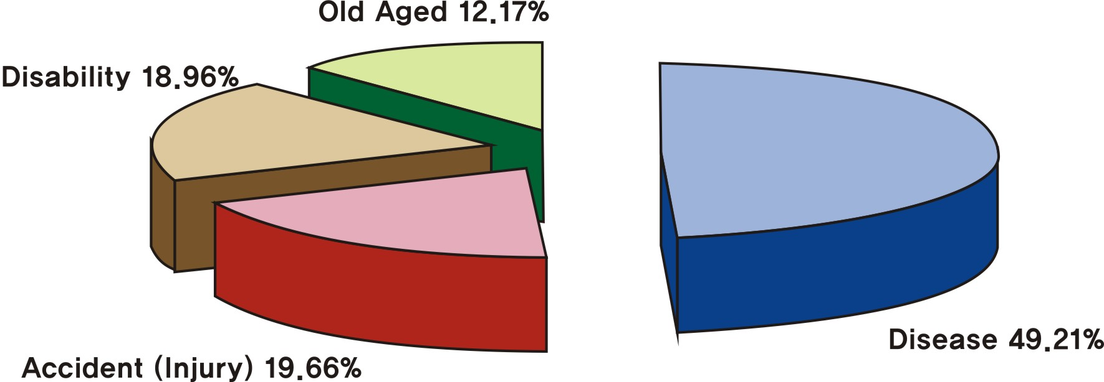

Chart 9. Causes of long term restricted activity

(5) Accidents and addictions
▪ The experience rate of serious accidents·addictions requiring hospitalization during the past year showed a total of 0.90%, male 1.13% and female 0.69% in which the male showed a higher disposition than the female. For every 1,000 population 9 people experienced serious accidents·addictions, male 11 and female 7.

Table 31. Rate of experience of serious accidents·addictions past 1 year preceding survey (unit: %)
 | Total(No) | Male | Female
Experience | 0.90 | 1.13 | 0.69
Inexperience | 99.12 | 98.87 | 99.31
Total | 100.00(23,198) | 100.00(11,311) | 100.00(11,887)
Data source: Busan Health Status and Medical Utilization Survey, 2004

▪ The causes for serious accidents·addictions showed that 48.25% were accrued to ‘traffic accidents’ being the highest and ‘fall ·slippage accidents’ with a 26.78% being the second highest. And in gender wise, both male and female had the most ‘car·transportation accidents’ as cause and ‘fall·slippage accidents’ next.

Table 32. Causes of serious accidents·addictions past 1 year preceding survey (unit: %)
 | Total(No) | Male | Female
Total(No) | 100.00(205) | 100.00(119) | 100.00(86)
Traffic accidents | 48.25 | 43.84 | 55.13
Fire·flame accidents | 0.33 | 0.55 | -
Fall ·slippage accidents | 26.78 | 24.95 | 29.63
Drowning accident | 0.39 | 0.64 | -
Violence | 2.07 | 1.99 | 2.20
Others | 19.87 | 25.42 | 11.22
Toxic chemicals accidents | - | - | -
Suicide | - | - | -
No respond | 2.31 | 2.62 | 1.82
Data source : Busan Health Status and Medical Utilization Survey, 2004

(6) Perceived Health Status
According to the 2004 data, 55.96% of the respondents perceived their health status as being very healthy or healthy. 24.79% responded that they were mediocre and 19.26% responded that they were unhealthy or very unhealthy. Male respondents, and young people showed a higher percentage that they were healthier than female respondents, and old people.
Table 33. Busan residents' perceived health status by gender and age. (unit: % (No))
Category |  | very healthy | healthy | ordinary | poor | very poor | Total
Gender | Male | 8.80 | 51.82 | 23.22 | 13.68 | 2.48 | 100(3,618)
Gender | Female | 3.91 | 47.37 | 26.35 | 19.20 | 3.17 | 100(4,216)
Age group | 20-29 | 14.61 | 59.28 | 19.47 | 6.26 | 0.39 | 100(1,059)
Age group | 30-39 | 8.56 | 57.92 | 24.05 | 8.20 | 1.27 | 100(1,751)
Age group | 40-49 | 5.22 | 54.24 | 26.34 | 12.19 | 2.02 | 100(1,933)
Age group | 50-59 | 3.06 | 46.30 | 28.70 | 19.10 | 2.83 | 100(1,237)
Age group | 60-69 | 2.14 | 34.45 | 27.15 | 30.64 | 5.62 | 100(1,090)
Age group | over 70 | 1.69 | 29.07 | 21.38 | 39.39 | 8.47 | 100(712)
Total |  | 6.36 | 49.6 | 24.79 | 16.44 | 2.82 | 100(7,834)
Data source : Busan Health Status and Medical Utilization Survey, 2004. p 52~53

The percentage of students who perceived their health status was ‘good’ or ‘very good’ was 63 % in Busan based on 2004 youth behavior risk factor surveillance. Male students (66.2%) showed better health, responding that their health state was good compared to female students (59.6%).

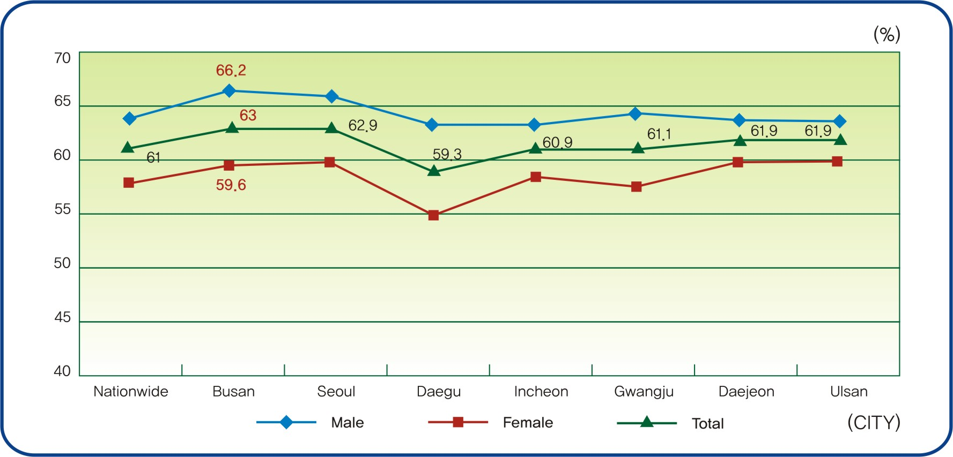
Chart 10. Perceived health status in adolescents by sex

Regardless of gender, compared to the health level 1of income which has the highest income level the lower income showed a low level of health and this tendency especially shows among the lowest income .
Females showed a higher level of unhealthiness than the males, however, in regards to income levels the males showed a higher level of unhealthiness than the females.

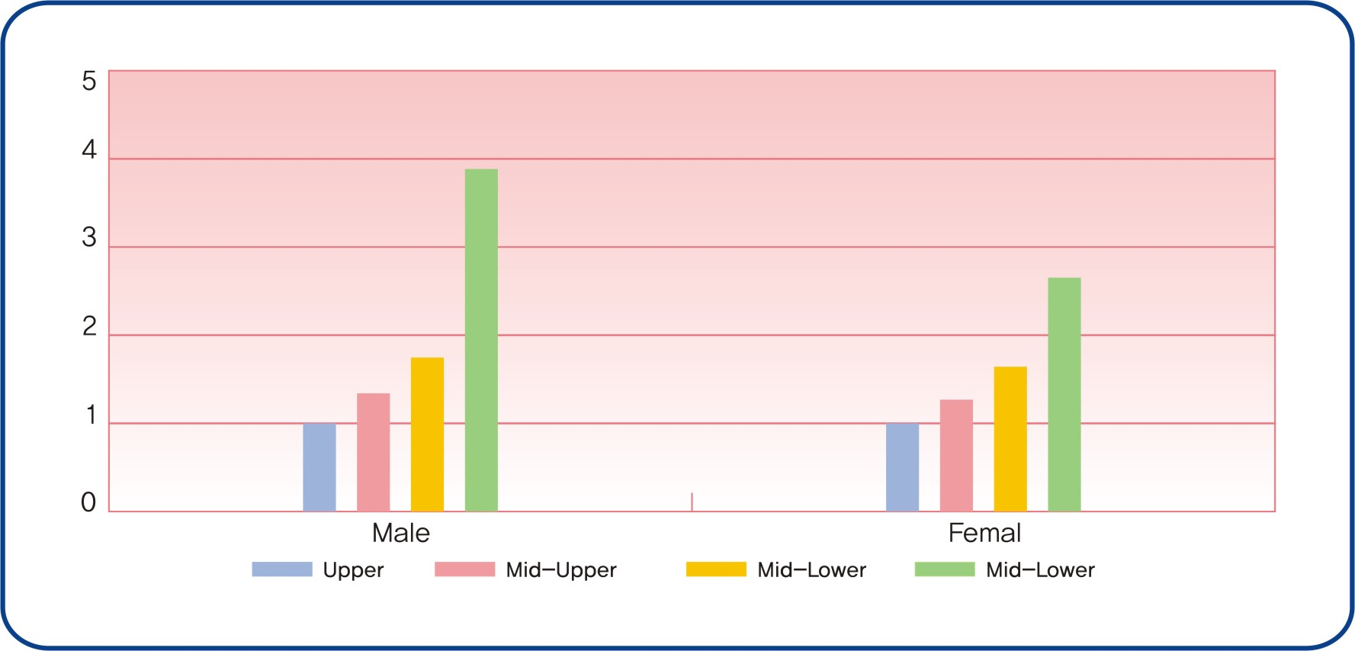
Chart 11. Perceived health status by income(15-64yr) (unit: per 1,000 population)

3. Health Behavior

(1) Smoking
The smoking rate in Busan was 29.9%. The male smoking rate of 53.33% was very high compared with that of females of 6.49%. Smoking in their 30s was the highest at 32.9% followed by the 40s at 31.5%, the 50s at 28.0%, the 20s at 25.1%, the 60s at 24.9%, and over 70 at 18.9%. It indicated that the smoking rate of young people was higher.
Table 34. Prevalence of cigarette smoking in Busan by gender and age. (unit: %(No))
Category |  | Current smoker | Ex-smoker | Non-smoker | Total
Gender | Male | 53.33 | 19.14 | 27.53 | 100(3,584)
Gender | Female | 6.48 | 2.26 | 91.26 | 100(4,156)
Age group | 20-29 | 25.12 | 4.82 | 70.05 | 100(1,043)
Age group | 30-39 | 32.88 | 7.16 | 59.96 | 100(1,739)
Age group | 40-49 | 31.54 | 10.29 | 58.17 | 100(1,926)
Age group | 50-59 | 27.49 | 12.78 | 59.73 | 100(1,240)
Age group | 60-69 | 24.92 | 12.57 | 62.51 | 100(1,080)
Age group | over 70 | 18.87 | 16.29 | 64.85 | 100(713)
Total |  | 28.22 | 10.11 | 61.67 | 100(7,740)
Data source : Busan Health Status and Medical Utilization Survey, 2004. p57~59

The prevalence rate of current cigarette smoking of adolescent who smoked cigarettes on a day and over of past 30days preceding the survey was 9.45% in Busan based on 2005 youth behavior risk factor surveillance. The prevalence rate of current cigarette smoking of female students was 7.4% and that of
male students was 12.1%.
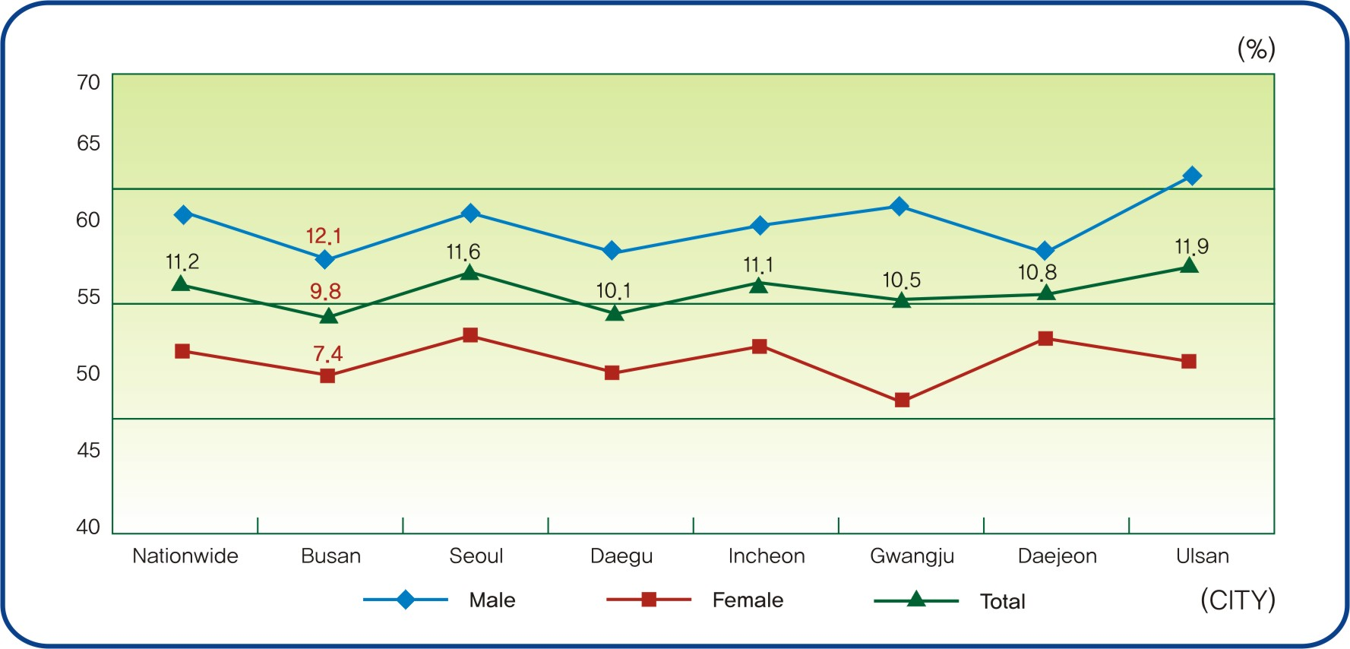
Chart 12. Prevalence of current cigarette smoking in adolescents

(2) Alcohol Drinking
The survey results showed that 61.58% of the respondents were current alcohol drinkers in Busan in 2004. The drinking rate of males was 77.32% while that of females was 47.95%. The rate of male frequent drinkers was 26.90% while that of females was 4.33%. As for the age group, the drinking rate in their 30s was the highest at 74.22%, followed by the 20s at 74.48%, the 40s at 68.41%, and the 50s at 56.67%. Among the age groups over 60, the older the person, the less he or she drank. Those in their 30s and 40s who responded that they were frequent drinkers totaled 16.41% and 20.32% respectively.
Table 35. Prevalence of alcohol drinker in Busan by gender and age. (unit:% (No))
Category |  | current drinker |  |  |  | Ex-  drinker | Non-  drinker | Total
 |  | Frequently | Sometimes | Rarely | Total | Ex-  drinker | Non-  drinker | Total
Gender | Male | 26.90 | 37.79 | 12.63 | 77.32 | 4.23 | 18.45 | 100(3,601)
Gender | Female | 4.33 | 27.74 | 15.88 | 47.95 | 1.42 | 50.64 | 100(4,175)
Age group | 20-29 | 10.90 | 46.55 | 17.03 | 74.48 | 1.54 | 23.98 | 100(1,054)
Age group | 30-39 | 15.78 | 41.10 | 17.34 | 74.22 | 1.59 | 24.19 | 100(1,750)
Age group | 40-49 | 20.32 | 34.22 | 13.87 | 68.41 | 1.76 | 29.83 | 100(1,931)
Age group | 50-59 | 16.41 | 26.13 | 14.13 | 56.67 | 3.37 | 39.95 | 100(1,243)
Age group | 60-69 | 10.74 | 21.84 | 11.68 | 44.26 | 4.27 | 51.48 | 100(1,082)
Age group | over 70 | 8.83 | 11.86 | 8.96 | 27.65 | 6.57 | 65.78 | 100(716)
Total |  | 14.81 | 32.40 | 14.37 | 61.58 | 2.74 | 35.69 | 100(7,776)
Data source: Busan Health Status and Medical Utilization Survey, 2004 p 87~88
The prevalence rate of current alcohol drinking of adolescent who drank alcohol on a day and over of past 30days preceding the survey was 26.1% in Busan based on 2005 youth behavior risk factor surveillance. The prevalence rate of current alcohol drinking of female students was 26.1% and that of male students was 26.0%.

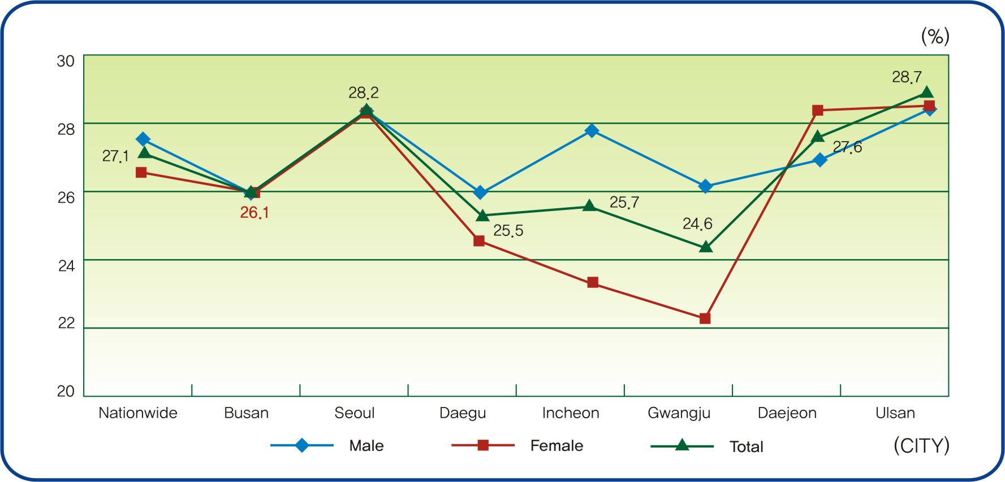
Chart 13. Prevalence of current alcohol drinking in adolescents
(3) Physical activity.
The table 21 shows that the rate of physical activities of the Busan people was 41.9%. The male physical activity rate was 45.1%, higher than that of females at 37.3%. As for the age groups, the physical activity rate of those in their 60s was the highest at 49.0%, followed by the 50s at 48.6%, the 40s at 40.9%, the 20s at 37.9%, the 30s at 34.2%, and over 70 at 36.1%.
A pattern of physical activity is regular if activities are performed:
Regular moderate physical activity is defined as 5 or more days of the week if moderate-intensity activities (in bouts of at least 10 minutes for a total of at least 30 minutes per day);
Regular vigrous physical activity is defined as 3 or more days of the week if vigorous-intensity activities (for at least 20-60 minutes per session).
Physical inactivity is defined as no leisure-time physical activity.
Table 36. Physical activity in Busan by gender and age. (unit:% (No))
Category |  | Regular Physical activity |  |  |  | Physical inactivity | Total
 |  | Regular Physical  activity | Regular vigorous Physical  Activity1) | Regular moderate Physical activity2) | Total | Physical inactivity | Total
Gender | Male | 20.7 | 13.8 | 10.6 | 45.1 | 51.5 | 100.0(3,618)
Gender | Female | 17.4 | 10.1 | 9.8 | 37.3 | 59.0 | 100.0(4,216)
Age group | 20-29 | 17.3 | 15.2 | 5.4 | 37.9 | 57.2 | 100.0(1,062)
Age group | 30-39 | 15.9 | 12.3 | 6.0 | 34.2 | 57.0 | 100.0(1.758)
Age group | 40-49 | 18.7 | 13.3 | 8.9 | 40.9 | 52.9 | 100.0(1,948)
Age group | 50-59 | 21.8 | 12.3 | 14.5 | 48.6 | 50.5 | 100.0(1,250)
Age group | 60-69 | 23.5 | 9.3 | 16.2 | 49.0 | 55.0 | 100.0(1,094)
Age group | over 70 | 17.3 | 4.5 | 14.3 | 36.1 | 66.4 | 100.0(723)
Total |  | 19.4 | 12.0 | 10.5 | 41.9 | 54.5 | 100.0(7,834)
Data source: Busan Health Status and Medical Utilization Survey, 2004. p115
The prevalence rate of vigorous physical activity of adolescent who activities that made students sweat and breathe hard for 20 minutes and over on 3 days and over of the 7 days preceding the survey was 31.9% in Busan based on 2005 youth behavior risk factor surveillance. The prevalence rate of current alcohol drinking of female students was 13.8% and that of male students was 48.2%.

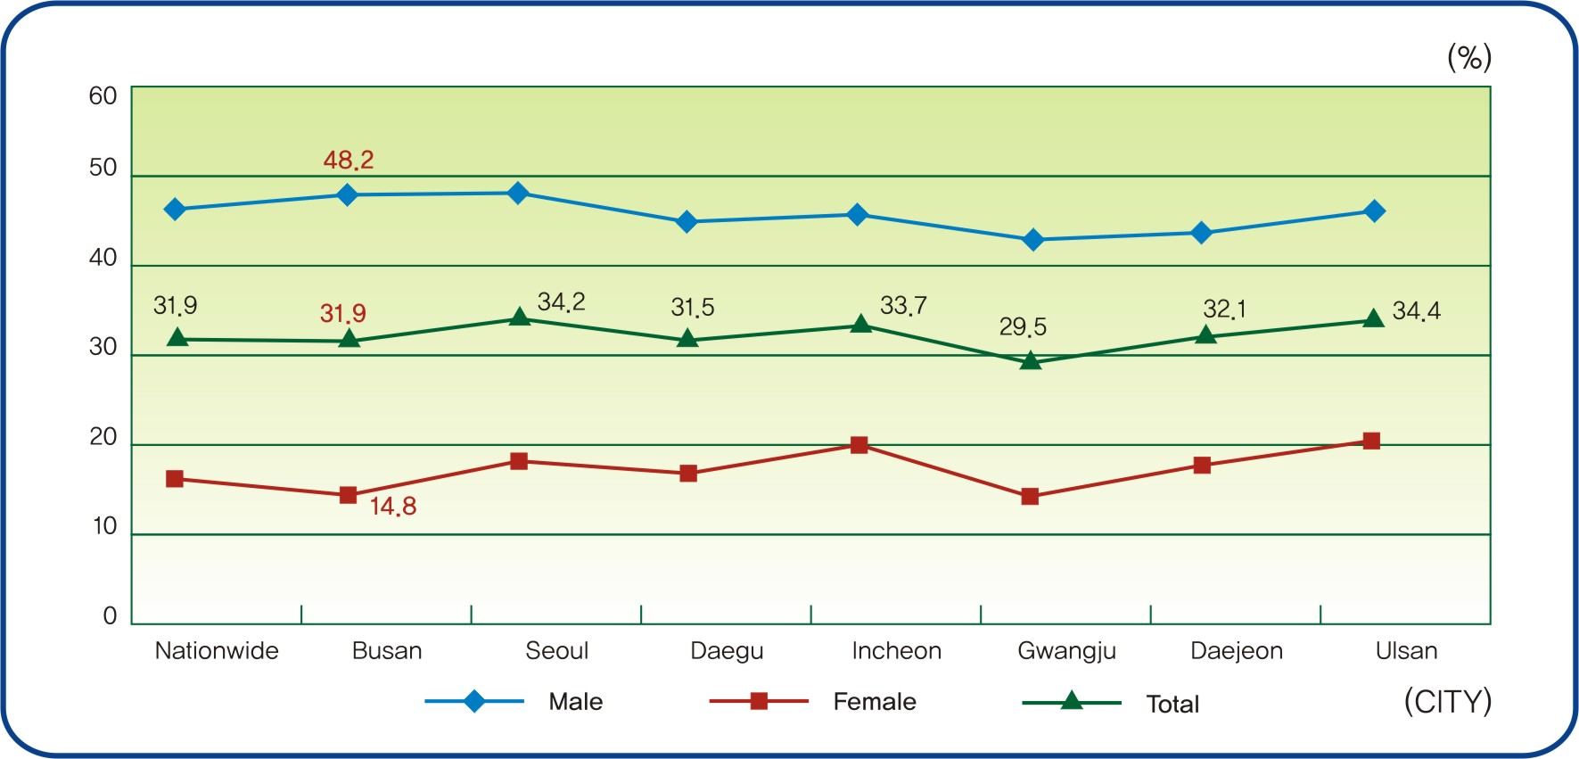
Chart 14. Prevalence of vigorous physical activity in adolescents
(4) Obesity
Male obesity prevalence rate was 1.6% while that of females was 1.3%. Male overweight prevalence rate was 25.0% while that of females was 17.7%. The survey results showed that 1.5% of respondents were obese and 22.5% were overweight in urban areas In rural areas, the obesity prevalence rate was 1.4% and the overweight rate was 19.8%. As for age groups, those in their 50s was the highest with the obesity rate of 4.5% and the overweight rate of 28.8% followed by the 60s with the overweight rate of 26.6% and the obesity rate of 1.1%. The following groups were the order of the 40s, the 30s, the 20s, and over 70. The underweight rate was 9.3% in their 20s and 4.6% in the 30s.
Table 37. Busan residents' perceived obesity in Busan by gender and age . (unit:% (No))
Category |  | Underweight | Normal | Overweight | Obese | Total
Gender | male | 23.3 | 55.5 | 18.8 | 2.5 | 100(3,593)
Gender | female | 14.4 | 54.6 | 27.9 | 3.1 | 100(4,187)
Age group | 20s | 20.4 | 56.6 | 20.5 | 2.4 | 100(1,057)
Age group | 30s | 15.7 | 53.2 | 26.4 | 4.7 | 100(1,750)
Age group | 40s | 16.4 | 55.2 | 25.7 | 2.8 | 100(1,936)
Age group | 50s | 15.7 | 55.7 | 25.6 | 3.0 | 100(1,241)
Age group | 60s | 20.1 | 56.5 | 21.8 | 1.6 | 100(1,084)
Age group | over 70 | 30.1 | 53.4 | 15.8 | 0.7 | 100(713)
 |  | 18.4 | 55.0 | 23.7 | 2.8 | 100(7,781)
Data source: Busan Health Status and Medical Utilization Survey, 2004. p 142
The prevalence rate of obesity of adolescent who were 120% and over for Broca’s index based self-recorded data was 9.6% in Busan based on 2005 youth behavior risk factor surveillance. The prevalence rate of current alcohol drinking of female students was 12.7% and that of male students was 6.3%.

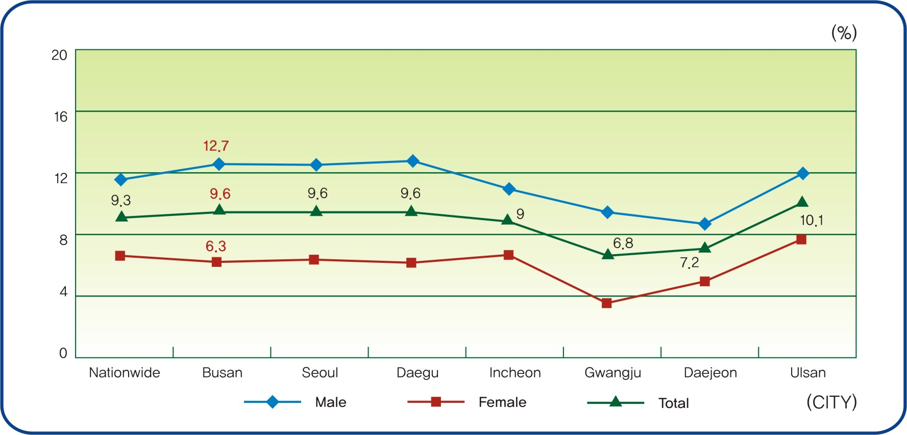
Chart 15. Prevalence of obesity in adolescents based self-recorded data

(5) Diet behavior
The 3 times diet per day is commonly known to be the most important , but busy city dwellers tend to skip breakfast very often. 56.4% of male responds to always having 3 times diet per day, whereas just a little over half, 52.7% of female do. The 3 times diet per day in their 20s was the lowest at 29.9%.

Table 38. Diet frequency and regularity in Busan by gender and age (unit:% (No))
Category |  | 3 times/day | 2 times/day | Irregular | Very irregular | Total
Gender | Male | 56.4 | 21.2 | 15.3 | 7.1 | 100.0(3,568)
Gender | Female | 52.7 | 24.6 | 14.6 | 8.1 | 100.0(4,145)
Age group | 20-29 | 29.9 | 39.3 | 15.7 | 15.1 | 100.0(1,047)
Age group | 30-39 | 45.0 | 29.1 | 15.9 | 9.9 | 100.0(1,730)
Age group | 40-49 | 53.2 | 22.6 | 17.2 | 7.0 | 100.0(1,925)
Age group | 50-59 | 64.4 | 16.9 | 14.6 | 4.0 | 100.0(1,224)
Age group | 60-69 | 71.1 | 12.9 | 11.7 | 4.2 | 100.0(1,077)
Age group | over 70 | 74.5 | 11.1 | 10.4 | 3.9 | 100.0 ( 711)
Total |  | 54.4 | 23.1 | 14.9 | 7.6 | 100.0 (7,713)
Data source: Busan Health Status and Medical Utilization Survey, 2004. p132
The prevalence rate of skipping breakfast of adolescent who had eaten breakfast on 2 days and less during the 30 days preceding the survey was 25.0% in Busan based on 2005 youth behavior risk factor surveillance. The prevalence rate of current alcohol drinking of female students was 24.9% and that of male students was 25.0%.
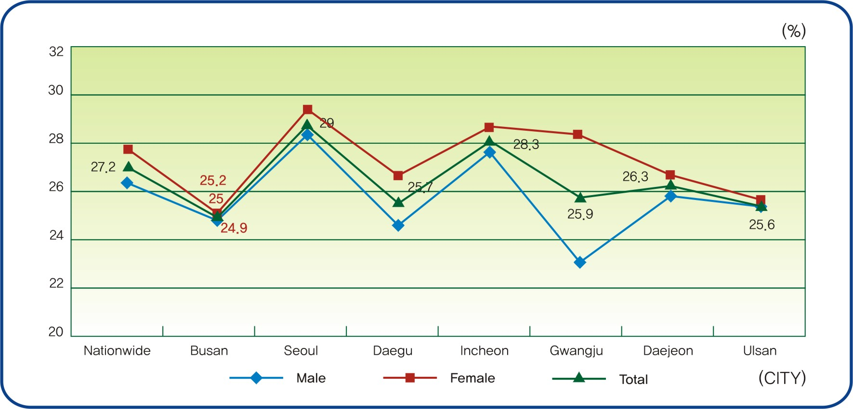
Chart 16. prevalence of skipping Breakfast in adolescents 10

(6) Mental health
46.4% of subjects in the survey responded that the level of stress was ‘very high’ or ‘high’. 46.6% of male respondents answered that the level of stress was very high or high while 39.8% of female respondents reported high stress. As for age groups, 48.5% of those in their 40s showed the highest figures followed by the 50s of 46.5%, 30s of 44.7%, the 60s of 39.8%, the 20s of 37.3%, and over 70 of 34.9%.
Table 39. Stress in Buan by gender and age. (unit:% (No))
N |  | Very high | high | low | very low | total
Gender | Male | 8.5 | 38.1 | 43.3 | 10.1 | 100(3,607)
Gender | Female | 7.1 | 32.7 | 48.3 | 11.8 | 100(4,203)
Age grop | 20-29 | 6.3 | 31.0 | 52.5 | 10.3 | 100(1,061)
Age grop | 30-39 | 8.3 | 36.4 | 48.2 | 7.0 | 100(1,752)
Age grop | 40-49 | 8.5 | 40.0 | 43.3 | 8.1 | 100(1,942)
Age grop | 50-59 | 7.8 | 36.7 | 44.8 | 10.7 | 100(1,245)
Age grop | 60-69 | 6.6 | 33.2 | 45.6 | 14.7 | 100(1,092)
Age grop | over 70 | 8.2 | 26.7 | 40.7 | 24.5 | 100(719)
Total |  | 7.8 | 35.4 | 45.8 | 11.0 | 100(7,810)
Data source: Busan Health Status and Medical Utilization Survey, 2004 p 147~148
The percentage of students who felt stress everyday was ‘much’ or ‘very much’ was 43.3% % in Busan based on 2005 youth behavior risk factor surveillance. Female students(48.1%) felt more stress than male students (38.9%).
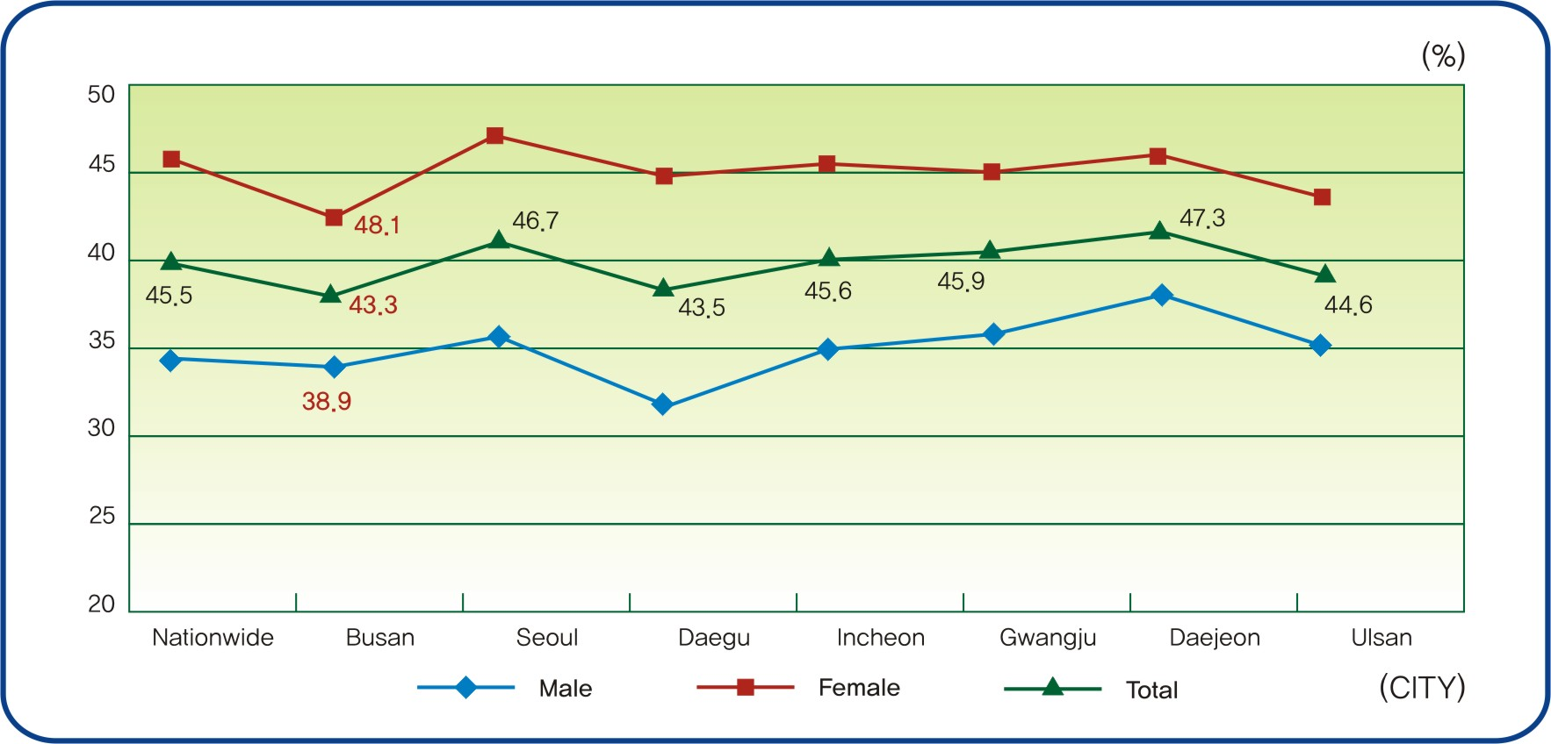
Chart 17. Prevalence of perceived stress in adolescents

The percentage of students who considered attempting suicide everyday was 23.0% in Busan based on 2005 youth behavior risk factor surveillance. Female students(27.0%) considered more attempting suicide than male students(19.1%).,

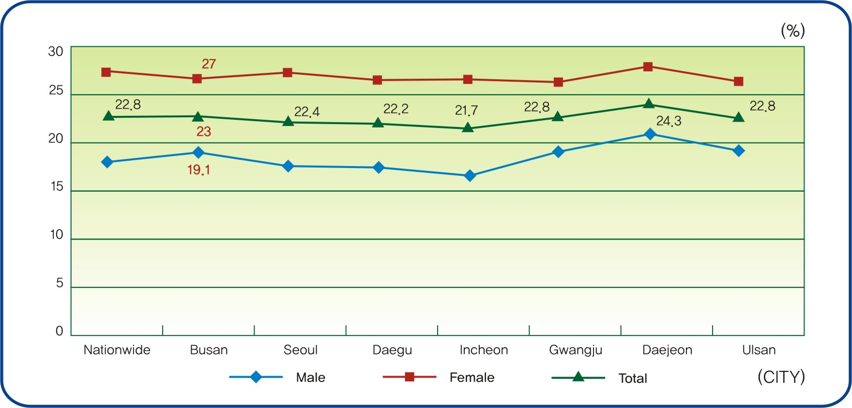
Chart 18. Prevalence of considered attempting suicide in adolescents

(7) Medical check-ups
The respondents who had taken medical check-ups for the past 2 years was 48.5%. Males took medical check-up more than females indicating 53.3%, 44.3% for each group. As for age groups, the medical check-up rate for people in their 50s was the highest at 59.6% followed by the 60s at 53.0% and the 40s at 52.8%.

Table 40. Medical check-up during last two years by gender and age. (unit:% (No))
Category |  | Checkup | Non-Checkup | Total
Gender | Male | 1,941(53.3) | 1,701(46.7) | 3,642(100)
Gender | Female | 1,867(44.3) | 2,347(55.7) | 4,214(100)
Age group | 20-29 | 361(35.1) | 667(64.9) | 1,028(100)
Age group | 30-39 | 743(42.0) | 1,026(58.0) | 1,767(100)
Age group | 40-49 | 1,048(52.8) | 937(47.2) | 1,985(100)
Age group | 50-59 | 752(59.6) | 510(40.4) | 1,262(100)
Age group | 60-69 | 571(53.0) | 506(47.0) | 1,077(100)
Age group | over 70 | 343(46.5) | 395(53.5) | 738(100)
Total |  | 3.817(48.5) | 4,048(51.5) | 7,856(100)
Data source: Busan Health Status and Medical Utilization Survey, 2004. p153

(8) Public health Education
▪ The proportion of each health education received on no smoking, no drinking, exercise and diet during the past year was a low level of 3.85%, 2.78%, 4.09%, 3.20% respectively.
Physical Environment and social Infrastructure

Table 41. Educational experience for last one year among adolescents. (unit: %)
Category |  | Cigarette smoking | Alcohol Drinking | Physical activity | Nutrition
Gender | Male | 4.86 | 3.52 | 4.39 | 2.66
Gender | Female | 2.97 | 2.14 | 3.84 | 3.97
Age group | 20-29 | 9.49 | 6.99 | 8.07 | 6.59
Age group | 30-39 | 4.33 | 2.80 | 4.47 | 3.34
Age group | 40-49 | 3.57 | 2.66 | 4.06 | 3.28
Age group | 50-59 | 2.62 | 2.43 | 3.66 | 2.55
Age group | 60-69 | 1.56 | 0.84 | 1.73 | 1.28
Age group | over 70 | 0.51 | 0.27 | 1.66 | 1.28
Total |  | 3.85 | 2.78 | 4.09 | 3.20
Data source: Busan Health Status and Medical Utilization Survey, 2004. p175-176

4. Public Health Policies and Services

(1) Health Resources
1) Number of medical Facilities (Medical Institutions)
In 2005, there were 27 general hospitals in Busan city. There were 59 hospitals and 2,052 clinics, an increase of 569 from 1,483 in 1998. There were 968 dental clinics, an increase of 154 from 814 in 1998. There were 837 oriental medical clinics in 2005.

Table 42. Number of Medical Institutions.
Year | Total | General hospitals | Hospitals | Clinics | Dental clinics | Oriental medicine clinics | Mid-wife clinics | Attached clinics | Health centers | Health  sub-centers | Primary health care centers
1998 | 3,077 | 25 | 44 | 1,483 | 814 | - | 40 | 28 | 16 | 8 | 6
1999 | 3,258 | 25 | 49 | 1,608 | 852 | - | 37 | 17 | 16 | 8 | 6
2000 | 3,392 | 26 | 52 | 1,692 | 876 | - | 33 | 18 | 16 | 8 | 6
2001 | 3,591 | 26 | 46 | 1,859 | 889 | - | 31 | 15 | 16 | 8 | 6
2002 | 3,766 | 26 | 52 | 1,962 | 922 | - | 26 | 14 | 16 | 8 | 5
2003 | 3,834 | 27 | 56 | 1,997 | 933 | - | 21 | 13 | 16 | 8 | 5
2004 | 3,891 | 26 | 57 | 2,014 | 948 | 783 | 18 | 12 | 16 | 8 | 5
2005 | 4,000 | 27 | 59 | 2,052 | 968 | 837 | 15 | 13 | 16 | 8 | 5
Data Sources: Busan Statistical Yearbook 2005.

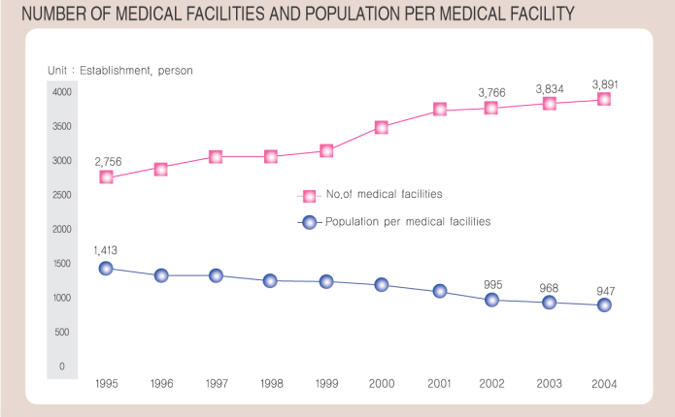
Chart 19. Number of Medical Facilities and Population per Medical Facility

2) Human resources
There were 28,794 medical personnel in Busan 2005. There were 1,321 more doctors, increasing from 4,327 in 1998 to 5,648 in 2005. The number of dentists increased from 1,016 to 1,239 and oriental medical doctors increased from 708 to 979. The number of midwives decreased from 279 to 191. The number of nurses increased more, from 4,478 in 1998 to 7,250 in 2005. The number of nurses aids increased from 6,572 in 1998 to 9,176 in 2005. The number of medical technicians increased more from 2,577 to 3,826. The number of medical record technicians increased from 170 in 1998 to 198 in 2005.

Table 43. Number of medical personnel employed in medical institutions.
Year | Total | Physicians | Dentist | Oriental medical doctors | Mid-wives | Nurses | Nurse Aids | Medical technicians | Medical record technicians | Pharma-cists
1998 | 20,434 | 4,327 | 1,016 | 708 | 279 | 4,478 | 6,572 | 2,577 | 170 | 307
1999 | 22,136 | 4,754 | 1,089 | 747 | 273 | 4,888 | 7,132 | 2,778 | 167 | 308
2000 | 22,986 | 4,750 | 1,114 | 776 | 282 | 5,234 | 7,563 | 2,842 | 174 | 251
2001 | 24,162 | 4,837 | 1,150 | 806 | 272 | 5,527 | 8,090 | 3,079 | 171 | 230
2002 | 24,343 | 5,051 | 1,104 | 854 | 259 | 5,913 | 7,643 | 3,120 | 167 | 232
2003 | 25,559 | 5,139 | 1,201 | 903 | 225 | 6,214 | 8,194 | 3,265 | 173 | 245
2004 | 26,057 | 5,424 | 1,132 | 936 | 212 | 6,528 | 9,005 | 3,372 | 187 | 261
2005 | 28,794 | 5,648 | 1,239 | 979 | 191 | 7,250 | 9,176 | 3,825 | 198 | 288
Data Sources : Busan Statistical Yearbook 2005.

3) Utilization of medical service
One patients with cancer out of 10 patients with cancer in Busan use medical institutions located in Seoul.
This shows polarization of medical service.
Table 44. Busan-residing cancer patients' usage rate of medical institutions located in Seoul for every major 6 cancers
cancer  residence | Total | Gastric cancer | Lung cancer | Liver cancer | Colon cancer | Breast cancer | Uterine cancer
Busan | 10.34 | 7.02 | 7.89 | 13.77 | 4.98 | 10.16 | 10.10
Incheon  Gyeongi-do | 52.68 | 46.38 | 48.4 | 57.79 | 47.01 | 55.84 | 49.42
Gangwon | 30.30 | 25.31 | 21.5 | 32.95 | 15.7 | 26.49 | 52.33
Chungbuk | 37.47 | 33.65 | 33.09 | 45.43 | 25.87 | 36.48 | 40.82
Daejeon  Cnungnam | 36.49 | 37.86 | 29.37 | 49.79 | 31.72 | 27.38 | 32.17
Jeonbuk | 27.24 | 28.33 | 19.38 | 35.41 | 25.05 | 21.28 | 20.95
Gwangju  Jeonnam | 34.60 | 34.68 | 32.24 | 42.92 | 30.49 | 27.93 | 26.59
Daegu  Gyeongbuk | 19.33 | 19.31 | 17.46 | 25.58 | 17.88 | 14.13 | 12.52
Gyeonnam  Ulsan | 15.65 | 12.78 | 11.07 | 19.19 | 12.91 | 17.84 | 16.29
Busan | 44.22 | 43.96 | 49.48 | 48.09 | 20.66 | 56.25 | 28.26
Data source: Busan Health Status and Medical Utilization Survey, 2004
Usage rate of medical institutions located in Seoul according to income levels showed distinctive differences between income level. Income level 1, having the highest level of income, showed a 1 out of 5 ratio. Income level 2 showed a 1 out of 10 and the remaining levels showed a 1 out of 15 ratio.
Table 45. Busan-residing cancer patients' self-sufficient rate according to income levels
District  residence | Total  (N) | Seoul | Busan | Incheon  Gyeongi-do | Gangwon | Chungbuk | Cnungnam  Daejeon | Gyeongbuk | Gwangju  Jeonnam | Daegu  Gyeongbuk | Gyeonnam  Ulsan | Busan
Busan
level 1 income | 2,723 | 20.42 | 76.72 | 0.26 | 0.00 | 0.33 | 0.04 | 0.33 | 0.44 | 0.37 | 1.10 | 0.00
level 2 income | 2,496 | 9.17 | 89.10 | 0.04 | 0.00 | 0.00 | 0.00 | 0.12 | 0.08 | 0.72 | 0.76 | 0.00
level 3 income | 2,116 | 6.43 | 89.98 | 1.51 | 0.00 | 0.05 | 0.05 | 0.05 | 0.38 | 0.71 | 0.85 | 0.00
level 4 income | 2,022 | 6.58 | 88.92 | 1.04 | 0.00 | 0.00 | 0.35 | 0.00 | 2.13 | 0.20 | 0.79 | 0.00
level 5 income | 2,896 | 6.46 | 89.68 | 0.55 | 0.24 | 0.00 | 0.21 | 0.07 | 0.45 | 0.97 | 1.31 | 0.07
level 6 income | 348 | 6.90 | 83.62 | 6.32 | 0.00 | 0.29 | 0.00 | 0.00 | 0.29 | 0.86 | 1.72 | 0.00
Data source : Busan Health Status and Medical Utilization Survey, 2004
According to income levels, high income level cancer patients of Busan showed a 16.38% usage rate for the 4 major hospitals whereas the lower income levels showed only a 3-4%. While the higher income levels showed a high usage rate for Tertiary Hospital, the lower levels showed a higher usage rate for general hospitals, hospitals and clinics.
Table 46. Busan-residing cancer patients' hospitalization rate according to income level and type of medical institution
 | Total  (N) | Tertiary Hospital |  |  |  | Genera  hospital | hospitals,  clinics
 | Total  (N) | major 4 hospitals | in Seoul* | in local† | sum | Genera  hospital | hospitals,  clinics
level 1 income | 2,723 | 16.38 | 3.01 | 55.38 | 74.77 | 19.46 | 5.77
level 2 income | 2,496 | 4.69 | 3.61 | 62.18 | 70.48 | 24.52 | 5.01
level 3 income | 2,116 | 3.02 | 1.51 | 66.16 | 70.69 | 23.87 | 5.43
level 4 income | 2,022 | 4.80 | 1.34 | 59.84 | 65.98 | 28.19 | 5.84
level 5 income | 2,896 | 3.73 | 1.73 | 51.21 | 56.67 | 34.94 | 8.39
level 6 income | 348 | 4.31 | 0.00 | 2.87 | 7.18 | 74.71 | 18.10
Data source: Busan Health Status and Medical Utilization Survey, 2004

Major 4 hospitals : Seoul National University Hospital , Severance Hospital, Seoul Asan Medical Center, Seoul Samsung Hospital
In Seoul : Tertiary Hospital located within the Seoul area precluding the major 4 hospitals
In Local : Tertiary Hospital located within the local districts

Being the second biggest city, though, with a population of 4000000 Busan Medical Center is practically the only public hospital operated by the city. And as for metropolitan based hospitals, Pusan University Hospital shows little or no difference at all with private hospitals.
Public health center staffs, being one of the main labor forces of the public health medical plan, are only half of what Seoul has and relatively smaller compared to other city., This shows weaknesses of of public health medicals.

Table 47. public health center staff status of major city
 | Total population | No. of National Basic Livelihood Recipients | No. of staff in Health  center | No. of staff in Health  Sub-center | Total no. of health centers | A | B | C | D
Seoul | 10,167,344 | 169,251 | 2,152 | 0 | 25 | 86.1 | 86.1 | 21.2 | 12.7
Busan | 3,638,293 | 114,936 | 591 | 38 | 16 | 36.9 | 39.3 | 17.3 | 5.5
Daegu | 2,511,306 | 79,904 | 378 | 42 | 8 | 47.3 | 52.5 | 16.7 | 5.3
Incheon | 2,600,495 | 58,008 | 385 | 97 | 10 | 38.5 | 48.2 | 18.5 | 8.3
Gwangju | 1,401,745 | 52,419 | 275 | 11 | 5 | 55.0 | 57.2 | 20.4 | 5.5
Daejeon | 1,454,638 | 40,103 | 265 | 42 | 5 | 53.0 | 61.4 | 21.1 | 7.7
Ulsan | 1,087,648 | 17,567 | 181 | 56 | 5 | 36.2 | 47.4 | 21.8 | 13.5
Data source : health and welfare yearly statistics, 2004
A : number of staffs per every center
B : number of staffs for centers, branch centers, clinics per every center
C : number of staffs for centers, branch centers, clinics per 100000 population
D : number of staffs for centers, branch centers, clinics per 1000 Beneficiaries of the National Basic Life Security Allowance
(2) Public Health Services

1) Vaccination
The state of vaccination in Busan city is shown in Table 52. As of 2005, there were 96.539 PDT vaccination cases, 72,986 polio vaccination cases, 50,027 MMR vaccination cases, 76,551 Japanese encephalitis vaccination cases, 24,295 typhoid fever vaccination cases, 113,579 hepatitis vaccinations cases, and 124,638 influenza vaccination cases.

Table 48. Vaccinations against Major Communicable diseases (unit: case)
Year | DTaP | Poliomyelitis | MMR | Japanese encephalities | Typhoid fever | Hepatitis B | B.C.G | Influenza | Others
2001 | 125,899 | 103 796 | 83,807 | 164,547 | 25,414 | 132,560 | 37,647 | 216,006 | 178,978
2002 | 107,948 | 86,084 | 48,150 | 110,862 | 38,839 | 127,263 | 27,329 | 212,444 | 280,242
2003 | 102,982 | 83,201 | 47,778 | 87,696 | 29,671 | 122,512 | 28,385 | 322,098 | 600,610
2004 | 104,374 | 85,019 | 52,909 | 82,874 | 28,489 | 116,404 | 26,968 | 542,323 | 19,692
2005 | 96,539 | 72,986 | 50,027 | 76,351 | 24,295 | 113,600 | 24,579 | 560,639 | 81,514
Data Sources : Busan Statistical Yearbook 2005.

2) Visiting health care
As for the public health visit projects of public health centers offered to the people in Busan, 55,549 patients in 37,549 households were registered and managed in 2004. The number of visiting nursing service was 1,060,358. Among them, there were 88,732 cases of discovery of new cases and inspection, 114,396 cases of patient management and symptom control, 77,450 cases of medication management, and 226,576 cases of individual education and counseling.

Table 49. Home & Institution Visiting Health Service,
Year | Home visiting
Year | Administration & Registration |  | Home visiting health service
Year | Households | Household members | Total | Survey of new cases & inspection |  | Medical examination |  | Medi-  cation | Treat-ment | Patient management & symptom control
2001 | 9,926 | 26,414 | 587,803 | 66,144 |  | 59,184 |  | 87,523 | 62,542 | 106,773
2002 | 18,620 | 37,145 | 748,750 | 60,021 |  | 54,108 |  | 55,408 | 65,808 | 124,735
2003 | 25,092 | 51,926 | 956,099 | 84,669 |  | 58,762 |  | 89,719 | 63,439 | 185,008
2004 | 37,549 | 55,460 | 1,060,358 | 88,732 |  | 104,849 |  | 114,396 | 77,450 | 226,576
Year | continued Home visiting |  |  |  |  |  |  |  | Institutions visiting
Year | Home visiting health service |  | Referrals |  |  |  |  | Family health record | No. of facilities | No. of inmates
Year | Education & counseling |  | Other division in health center | Special medical clinics | Adminis-trative support |  | Welfare support | Family health record | No. of facilities | No. of inmates
Year | Group Edu | Individual Edu.
2001 | 211 | 760 | 3 905 | 3 468 | 296 |  | 41 910 | 9 926 | - | -
2002 | 94 865 | 269 157 | 4 203 | 5 367 | 1 651 |  | 34 081 | 6 047 | - | -
2003 | 240 160 | 230 279 | 5 906 | 3 869 | 1 100 |  | 39 439 | 10 243 | 337 | 12 979
2004 | 44 541 | 372 323 | 10 860 | 4 532 | 1 593 |  | 49 595 | 17 601 | 331 | 11 944
Data Sources: Busan Statistical Yearbook 2005

3) Maternal and Child Health care
In 2005, 3,378 pregnant women and 12,918 infants and children were registered and managed in public health centers in Busan. 1,426 pregnant women and 1,919 infants and children had medical check-ups.

Table 50. Maternal and Child Health care Activities
Year | Maternal and Child Health care Program |  | Health examinations Activities
Year | Pregnant woman | Infant & Children | Pregnant woman | Infant & Children
1998 | 3,642 | 21,398 | 1,390 | 1,410
1999 | 3,203 | 20,560 | 2,285 | 1,471
2000 | 2,676 | 17,929 | 1,747 | 1,560
2001 | 2,387 | 16,120 | 1,368 | 1,669
2002 | 2,140 | 14,622 | 1,084 | 1, 452
2003 | 2,216 | 14,679 | 1,102 | 1,381
2004 | 2,595 | 12,927 | 1,356 | 2,262
2005 | 3,378 | 12,918 | 1,426 | 1,919
Data Sources: Busan Statistical Yearbook 2005
(3) Rescue Services
To protect citizen's lives and properties from fire accidents, we are not only prepared with firefighting equipment, but also with ongoing fire inspections of vulnerable areas, so that we can prevent fires in the first place as well as get the rescue squads into action at once. Especially, 119 rescue is working actively to protect endangered citizens. There are 6, 754 Firefighting water facilities (Hydrant 6,516, Water Supply 48, Water Tank 190) in Busan.
Table 51. Fire Equipment Status
Total | Fire Engines |  |  |  |  |  |  |  | Fire  Ship | Fire  Heli-  Copter
Total | Subtotal | Pump  Car | Water  Tank  Truck | Falling  Ladder  Vehicles | Chemical  truck | Ambul-  ances | Rescue  Car | Others | Fire  Ship | Fire  Heli-  Copter
356 | 351 | 70 | 59 | 23 | 14 | 55 | 11 | 119 | 3 | 2

Results of Emergency Activities
Total | Acute & Chronic  Disease | Accidental  Injury |  | Traffic  Accidents |  | Medicinal  poisoning |  | pregnant  women  and  nursing  mothers |  | Gas poisoning |  | Others
80,546 | 47,474 | 17,472 |  | 8,357 |  | 994 |  | 199 |  | 44 |  | 6,006
Fire Cases and Fire Damage Status
Classifications |  |  |  |  | 2000 |  | 2001 |  | 2002 |  | 2003 |  | 2004
Cases of Fires |  |  |  |  | 2,190 |  | 2,123 |  | 2,057 |  | 1,979 |  | 1,945
Casualties (Person) |  |  | Dead |  | 32 |  | 33 |  | 18 |  | 36 |  | 28
 |  |  | Injured |  | 116 |  | 118 |  | 102 |  | 136 |  | 146
Value of Damages  (100 million won) |  |  |  |  | 50 |  | 43 |  | 39 |  | 30 |  | 27
Data Sources: Busan Statistical Yearbook 2005

(4) Sports Facilities
The state of sports facilities on Busan is shown in Table 45. As for athletic facilities, there were 5 gymnasiums, 2 sports complex, 2 tennis courts, 2 swimming pools and 1 firing range in 2004. As for registered sports facilities, there were 3 golf courses, 3 ice rink, and 10 sports complex. Moreover, 41 swimming pools, 822 exercise hall, 42 bowling alleys, 5 tennis courts, 138 golf practice ranges, 493 physical training centers, 134 aerobic centers, 965 billiard halls, 1 ballrooms, and 61 ballroom dance schools are reported .
Moreover, as for youth training facilities, there were 7 training halls, 9 culture centers, 2 training centers, 3 camping sites, and 1 youth hostels in Busan.

Table 52. Public Sports Facilities (unit : Place, m2 )
Year | Athletic fields |  |  |  |  |  |  |  |  |  | Registered sports facilities
Year | Gymnasiums |  | Sports complex |  | Tennis courts |  | Swimming pools |  | Firing ranges |  | Golf  course | Ice rink | Sports  complex
Year | Place | Area | Place | Area | Place | Area | Place | Area | Place | Area | Golf  course | Ice rink | Sports  complex
2000 | 2 | 4,590 | 1 | 15,178 | 1 | 5,402 | 1 | 2,228 | 1 | 731 | 2 | 2 | 13
2001 | 2 | 4,770 | 2 | 105,496 | 1 | 5,402 | 1 | 2,228 | 1 | 731 | 2 | 2 | 13
2002 | 5 | 12,320 | 2 | 105,496 | 2 | 6,477 | 2 | 3,280 | 1 | 731 | 3 | 3 | 13
2003 | 5 | 12,320 | 2 | 105,496 | 2 | 6,477 | 2 | 3,280 | 1 | 731 | 3 | 3 | 13
2004 | 5 | 14,398 | 2 | 106,054 | 2 | 6,477 | 2 | 5,677 | 1 | 731 | 3 | 3 | 10

Year | Reported sports facilities
Year | Swim  ming  pool | Exercise  hall | Balling  alley | Tennis  courts | Golf  practice  range | Ballroom  dancing  school | Ballroom | Physical  training  center | Aerobics  Center | Billiard  room
2000  2001  2002  2003 | 39  40  51  45 | 694  739  755  794 | 53  52  55  44 | 8  8  7  7 | 109  118  114  122 | …  79  77  61 | …  4  2  1 | 363  423  453  471 | 123  122  129  131 | 1 228  1 098  990  972
2004 | 41 | 822 | 42 | 5 | 138 | 61 | 1 | 493 | 134 | 965
Data Source : Sports ＆ Youth Affairs Div.
Note : Gymnasium the area of athletic fields
Sports complex the area of buildings.
]

(5) Social Welfare Facilities
There were 85 social welfare facilities on Busan as of 2004. There were 22 welfare facilities for seniors accommodating 1,404, 23 welfare facilities for children accommodating 2,548, 17 welfare facilities for the disabled accommodating 1,401, 18 welfare facilities for women accommodating 595, 2 facility for the mentally disabled accommodating 538, 3 facilities for the homeless accommodating 394. Compared with to 1998, 12 welfare facilities for seniors, 17 welfare facilities for the disabled, 12 welfare facilities for women, 8 welfare facility for the mentally disabled and 5 welfare facilities for the homeless accommodating have been added .

Table 53. Social Welfare Institutions and Inmates (unit : Number, Person)
Year | Total |  | Children |  | Aged |  | Disabled |  | Woman |  | Psychiatric patients |  | Homeless
Year | Facilities | Inmates | Facilities | Inmates | Facilities | Inmates | Facilities | Inmates | Facilities | Inmates | Facilities | Inmates | Facilities | Inmates
1995 | 76 | 9,287 | 25 | 1,710 | 8 | 754 | 18 | 1,434 | 11 | 453 | 10 | 3,004 | 4 | 1,932
1998 | 80 | 10, 165 | 26 | 3 ,078 | 12 | 932 | 17 | 1,437 | 12 | 640 | 8 | 2 ,346 | 5 | 1,733
2000 | 73 | 7 ,123 | 22 | 1 ,681 | 13 | 1,025 | 18 | 1,484 | 13 | 552 | 2 | 569 | 5 | 1,812
2001 | 72 | 8 ,194 | 23 | 2 ,726 | 13 | 2,387 | 17 | 1,443 | 14 | 553 | 2 | 554 | 3 | 531
2002 | 75 | 6 ,611 | 23 | 2 ,630 | 14 | 1,096 | 17 | 1,371 | 16 | 573 | 2 | 557 | 3 | 384
2003 | 81 | 6 ,782 | 23 | 2 ,526 | 18 | 1,350 | 17 | 1,409 | 18 | 574 | 2 | 543 | 3 | 380
2004 | 85 | 6 ,878 | 23 | 2 ,548 | 22 | 1,404 | 17 | 1,401 | 18 | 595 | 2 | 538 | 3 | 394
Data Source : Social Welfare Div, Women's Policy Div.

5. Physical Environment and Social Infrastructure

(1) Air Quality
As for the concentration trend of air pollutants by year, O3, SO2, and NO2 have shown few changes.
The air quality in Busan in 2005 was shown in Table 40. The SO2 concentration in Busan was 0.006 ppm/year, the CO concentration was 0.5 ppm, and the NO2 concentration was 0.014 ppm. The quality of the air was relatively good. The acidity intensity of acid rain is measured by pH and below pH 5.6 is acid rain. The rainfall in Busan was pH 4.6, which was acid rain.
Table 54. Air pollution emission in Busan (unit: ppm(TSP: μg/m3 )
Classifications | Standard | 2000 | 2001 | 2002 | 2003 | 2004 | 2005
SO2  (Sulfurous Acid Gas) | 0.02ppm below | 0.010 | 0.008 | 0.007 | 0.006 | 0.007 | 0.006
CO  (Carbon Monoxide) | 9ppm below | 0.8 | 0.7 | 0.7 | 0.6 | 0.5 | 0.5
NO2  (Carbon Dioxide) | 0.005ppm below | 0.023 | 0.027 | 0.028 | 0.026 | 0.024 | 0.023
PM-10  (Minute dust) | 70ug/m3 below | 62 | 59 | 69 | 55 | 60 | 59
O3(Ozone) | 0.06ppm below | 0.022 | 0.025 | 0.024 | 0.024 | 0.024 | 0.023
Acid Rain | pH 5.6 below | 5.5 | 5.2 | 5.0 | 4.8 | 4.9 | 4.6
Pb(Lead) | 1.5ug/m3 | 0.1004 | 0.0694 | 0.0773 | 0.0511 | 0.0719 | 0.0468
Data Sources : Busan Statistical Yearbook 2005

Table 55. Anual Mean Levels of Air Pollutants in Selected Area, Busan, 2004
Area | SO2  (ppm/Year) | CO  (ppm/8hours) | NO2  (ppm/year) | O3  (ppm/8hours) | Dust  (ug/m2)/year | Acid rain  (PH)
Gwangbok-dong | 0.01 | 0.3 | 0.028 | 0.02 | 65 | 4.8
Yeonsan-dong | 0.006 | 0.7 | 0.021 | 0.02 | 44 | 4.9
Gamjeon-dong | 0.007 | 0.5 | 0.031 | 0.019 | 72 | -
Standard1) | less 0.02 | less 9 | less 0.05 | less 0.06 | less 70 | 5.6
Data Source: Ministry of Environment, Air Quality Monitoring Data, 2005
1) Air Environmental Information Open system, http://airmap.nier.go.kr/airinfo/

(2) Water Quality
With increased urban development, the demand for water and the need for quality water increased. Moreover, water was regarded as a precious resource. In order to live a daily life and prevent infectious diseases, a sufficient supply of safe drinking water is vital. Also, it is essential for the healthy city to offer measures to treat sewage in a scientific and environmentally-friendly way.
The water quality standard to protect human health and establish clean environment was set in Korea. These standards applies to river and lakes with 8 items related to living environments, such as pH, BOD(Biochemical Demand Oxygen), COD(Chemical Demand Oxygen), SS(Suspended solids, DO(Dissolved Oxygen), total number of colon bacilli, total nitrogen(TS) and total phosphorus(TP), and 9 items related to human health, such as Cd, AS, CN, Hg, organic phosphorus, Pb, Cr+6 and ABS. It is applied to rivers, lakes, and the sea. The water quality for rivers and lakes is classified into 5 levels of the grade(I～V).
In Busan, there are one national river(Nakdong River, 59.19km) and 44 local second level streams(192.15㎞),.

Table 56. Water quality (Unit : Biochemical Oxygen Demand (BOD) ppm)
Classifications | 1999 | 2000 | 2001 | 2002 | 2003 | 2004 | 2005
Ministry of Environment | 2.8 | 2.7 | 3.0 | 2.6 | 2.1 | 2.6 | 2.6
City Water Quality Research Institute | 2.7 | 2.3 | 3.1 | 2.6 | 2.2 | 2.6 | 2.7
Data source : Busan City Hall Homepage http://www.busan.go.kr

Table 57. Water Quality of Major River and Streams, Annual Mean Values, Busan, 2005.
River & Stream | Temp.  (℃) | DO  (㎎/ℓ) | BOD  (㎎/ℓ) | COD  (㎎/ℓ) | SS  (㎎/ℓ) | TN  (㎎/ℓ) | TP  (㎎/ℓ)
Nakdong River  (estuary dyke) | 8 | 10.5 | 1.5 | 4.4 | 5.8 | 2.775 | 0.069
Suyoung stream | 13 | 7.2 | 5.7 | 3.2 | 2.2 | 8.614 | 0.730
Daecheon stream | 11 | 10.1 | 2.2 | 1.0 | 1.0 | 2.823 | 0.054
Hakjang stream | 2 | 11.3 | 26.6 | 18.0 | 15.1 | 17.406 | 1.098
Dong stream | 10 | 4.0 | 3.4 | 4.0 | 6.6 | 2.110 | 0.177
Data Source: Ministry of Environment, Water Quality Monitoring Data, 2005

(3) Garbage disposal
The amount of garbage in Busan was 3,679 tons and all of it was collected and disposed. The main disposal method in 1998 was landfill but the amount of landfill has decreased. In 2005, recycled garbage took the largest portion - 63,410 tons, and the landfill was 723 tons. The amount of incinerator has decreased from 2002-2005 and 352 tons were incinerated.

Table 58. Waste Collection and Disposal
Year | Amount of discharged waste(ton) | Amount of waste disposal(ton) | Disposal ratio(%) | By type of waste disposal(ton)
 |  |  |  | Total | Landfill | Incineration | Recycling
1998 | 3,892 | 3,892 | 100 | 9, 29 | 3,012 | 960 | 5,857
1999 | 3,934 | 3,934 | 100 | 9, 90 | 2,622 | 914 | 6,354
2000 | 4,077 | 4,077 | 100 | 10,909 | 2,446 | 926 | 7,537
2001 | 4,053 | 4,053 | 100 | 11,656 | 2,482 | 717 | 8,457
2002 | 4,031 | 4,031 | 100 | 13,585 | 2,595 | 945 | 10,045
2003 | 3,980 | 3,980 | 100 | 13,738 | 3,074 | 845 | 9,819
2004 | 3,815 | 3,815 | 100 | 13,522 | 1,911 | 1,033 | 10,578
2005 | 3,679 | 3,679 | 100 | 63,410 | 525 | 723 | 2,430
Data Sources: Busan Statistical Year Book. 2005. p.376-377

(4) Transportation
As for the number of vehicle registrations on Busan , there were 123,948 in 2003 compared with 87,377 in 1998. The number of buses increased from 11,778 to 18,387 and trucks increased from 41,621 to 57,305. The number of special cars also increased from 189 to 336, a 41.86% increase for 5 years since 1998. This increase trend is expected to continue

Table 59. Number of Registered motor type vehicles (As of December 31, 2005)
Year | Total | Passenger car | Bus | Truck | Special car
2001 | 862,699 | 589,257 | 87,697 | 180,393 | 5,352
2002 | 921,084 | 638,173 | 87,903 | 189,023 | 5,985
2003 | 921,084 | 638,173 | 87,903 | 189,023 | 5,985
2004 | 966,417 | 679,433 | 83,048 | 196,740 | 7,196
2005 | 979,969 | 699,786 | 76,791 | 196,099 | 7,293
Data Sources : Busan Statistical Yearbook 2005

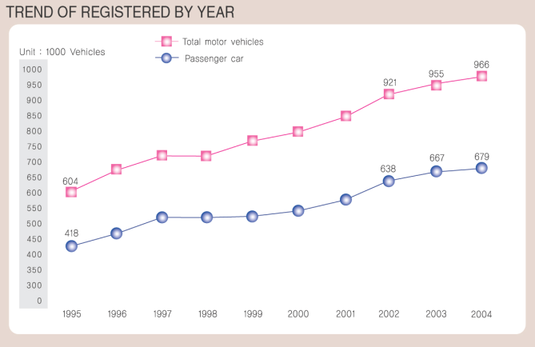
Chart 20. Trend of registered by year

Table 60. Vehicle Numbers by types of operation
Year | Total | Private | Commercial | Government
2000 | 812,369 | 749,380 | 60,052 | 2,937
2001 | 862,699 | 795,986 | 63,665 | 3,052
2002 | 921,084 | 850,522 | 67,414 | 3,148
2003 | 955,366 | 882,193 | 69,907 | 3,266
2004 | 966,417 | 892,033 | 71,073 | 3,311
Data Sources : Busan Statistical Yearbook 2005
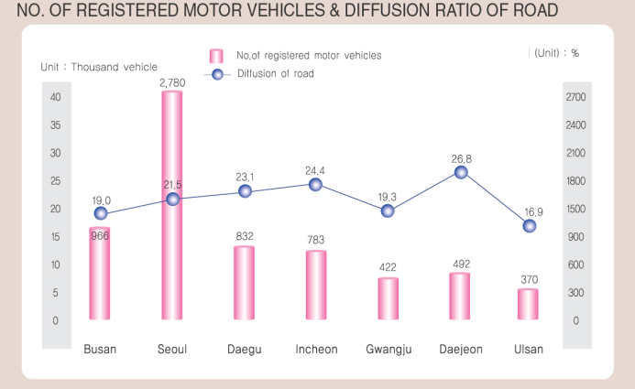
Chart 21. No. of registered motor vehicles and diffusion ratio of road

Table 61. Status of parking places (As of December, 2005)
Classification | Total | Road parking | Non-road private | Attached parking
Lots | 35,702 | 2,866 | 3,787 | 29,049
Capacity | 726,977 | 76,186 | 76,917 | 573,874
Data source: Busan City Hall Homepage http://www.busan.go.kr

(5) Parks and Green spaces
Busan's per capita amount of park area is 9.84m2, which is insufficient, but we are gradually promoting park development, and we built sports facility in order to host the 2002 Asian Games. The zoned area on Busan was 406,168 ㎢ in 2003. There is 337,496 ㎢ of green space, making up 83.09%. There were 232 parks, taking 377,407 ㎢. There were 7 natural parks of 360,362 ㎢ and 225 urban parks totaling 17,045 ㎢. Among urban parks, there were 136 children’s parks, 66 neighborhood parks, 19 urban natural parks, 2 cemeteries, and 2 sports parks.

Table 62. Parks.Amusement parks (unit : establishment, 1000m2)
Classification |  | Designated  Facilities |  | Completed |  | Preparing |  | Non-prepared
 |  | No. | Area | No. | Area | No. | Area | No. | Area
Total |  | 453 | 76,737 | 334 | 20,378 | 13 | 19,121 | 106 | 37,238
City  Park | Subtotal | 440 | 54,448 | 333 | 18,585 | 7 | 5,490 | 100 | 30,373
City  Park | Natural Park | 11 | 24,891 | 1 | 551 | 2 | 2,239 | 8 | 22,101
City  Park | Neighbor -hood Park | 103 | 25,290 | 47 | 16,039 | 4 | 1,050 | 52 | 8,201
City  Park | Gym Park | 3 | 2,220 | 1 | 13 | 1 | 2,201 | 1 | 6
City  Park | Cemetery Park | 5 | 1,357 | 5 | 1,357 | - | - | - | -
City  Park | Children's Park | 318 | 690 | 279 | 625 | - | - | 39 | 65
Amusement Park |  | 13 | 22,289 | 1 | 1,793 | 6 | 13,631 | 6 | 6,865
Data Sources: Busan Statistical Yearbook 2005

Table 63. Green Zone in Busan
Year | Planning area(1,000m2 ) | Green Zone area(1,000m2 ) | Rate of Green Zone(%)
1998 | 950,822,9 | 601,067.9 | 63.2%
1999 | 950,822,9 | 600,955.5 | 63.2%
2000 | 950,822,9 | 604,211.2 | 63.5%
2001 | 951,035,9 | 604,211.2 | 63.5%
2002 | 951,035,9 | 603,944.8 | 63.5%
2003 | 951,035,9 | 603,796.4 | 63.5%
2004 | 1,003,772,9 | 603,711.5 | 60.1%
2005 | 1,003,772,9 | 557,937.3 | 55.6%
Data Sources : Data Sources: Busan Statistical Yearbook 2005

Table 64. Number and Area of Park in Busan. (unit:1,000m2)
Year | Grand Total(A+B) |  | Urban parks(B)
Year | Number | Area | Total |  | Children's
Year | Number | Area | Number | Area | Number | Area
1998 | 412 | 563,530 | 412 | 563,530 | 306 | 5,484
1999 | 380 | 534,709 | 380 | 534,709 | 277 | 4,886
2000 | 377 | 529,944 | 377 | 529,944 | 285 | 5,427
2001 | 386 | 537,529 | 386 | 537,529 | 288 | 5,755
2002 | 388 | 537,504 | 388 | 537,504 | 288 | 5,755
2003 | 431 | 560,891 | 431 | 560,891 | 309 | 5,817
2004 | 431 | 544,054 | 431 | 544,054 | 312 | 5,886
Data Sources : Data Sources: Busan Statistical Yearbook, 2005.

Table 65. Type of Park in Busan (unit : Number, 100m2)
Year | City Park
Year | Total |  |  | Children's  Park |  | Neighborhood  Park |  |  | Natural Park  of city |  |  | Graveyard  Park |  | Gym park
Year | Number | Area |  | Number | Area | Number |  | Area | Number | Area |  | Number | Area | Number |  | Area
1998 | 412 | 563 530 |  | 306 | 5 484 | 88 |  | 272 194 | 11 | 250 077 |  | 5 | 13 634 | 2 |  | 22 142
1999 | 380 | 531 709 |  | 277 | 4 886 | 85 |  | 240 970 | 11 | 250 077 |  | 5 | 13 634 | 2 |  | 22 142
2000 | 386 | 537 529 |  | 285 | 5 427 | 83 |  | 247 385 | 11 | 248 902 |  | 5 | 13 673 | 2 |  | 22 142
2001 | 388 | 537 504 |  | 288 | 5 755 | 82 |  | 247 031 | 11 | 248 902 |  | 5 | 13 673 | 2 |  | 22 142
2002 | 388 | 537 504 |  | 288 | 5 755 | 82 |  | 247 031 | 11 | 248 902 |  | 5 | 13 673 | 2 |  | 22 142
2003 | 431 | 560 891 |  | 309 | 5 817 | 103 |  | 264 067 | 11 | 249 095 |  | 5 | 13 673 | 3 |  | 28 240
2004 | 431 | 544 054 |  | 312 | 5 886 | 99 |  | 250 789 | 11 | 248 921 |  | 6 | 16 256 | 3 |  | 22 203
Year | continued Urban parks
Year | Neighborhood |  |  |  | Urban natural |  |  |  | Grave yard |  |  |  | Sports
Year | Number |  | Area |  | Number |  | Area |  | Number |  | Area |  | Number |  | Area
1998 | 88 |  | 272,194 |  | 11 |  | 250,077 |  | 5 |  | 13,634 |  | 2 |  | 22,142
1999 | 85 |  | 240,970 |  | 11 |  | 250,077 |  | 5 |  | 13,634 |  | 2 |  | 22,142
2000 | 83 |  | 247,385 |  | 11 |  | 248,902 |  | 5 |  | 13,673 |  | 2 |  | 22,142
2001 | 82 |  | 247,031 |  | 11 |  | 248,902 |  | 5 |  | 13,673 |  | 2 |  | 22,142
2002 | 82 |  | 247,031 |  | 11 |  | 248,902 |  | 5 |  | 13,673 |  | 2 |  | 22,142
2003 | 103 |  | 264,067 |  | 11 |  | 249,905 |  | 5 |  | 13,673 |  | 3 |  | 28,240
2004 | 99 |  | 250 789 |  | 11 |  | 248,921 |  | 6 |  | 16,256 |  | 3 |  | 22,203
Data Sources: Busan Statistical Yearbook 2005
6. Socioeconomic Condition and Housing

(1) Education
It has been reported that the education state influences many deciding factors of health such as occupation, income, and health status. The school status of Busan was shown in Chart 33. The total number of schools was 991 in 2005. There were 381 kindergartens with 39,000 students, 285 elementary schools with 265,000 students, 166 middle schools with 146,000 students, 18 high schools with 12,006 students, 12 vocational high schools with 6,874 students, 3 junior colleges, 13 university of education, and 11 universities. There were 53,000 junior college students and 170,000 university students.
As for the education level? of adults on Busan shown in Table 34, almost half of the age group of over 60 didn’t finish elementary school and 30% of them graduated from elementary school, showing very low education level? However, as the age was younger, the education level? was higher. As for the age group of 40-50, 30% didn’t finish elementary school or graduated from elementary school and 35% graduated from high school. In contrast, most of the age group of 20-39 graduated from college

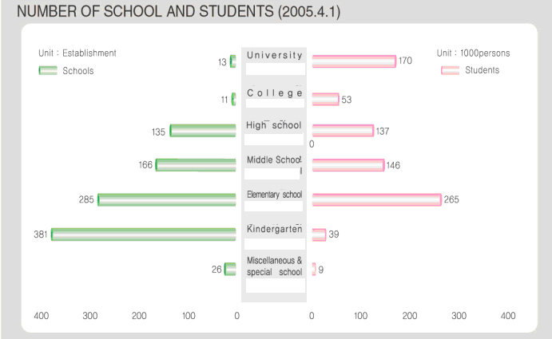
Chart 22. Number of schools and students in Busan

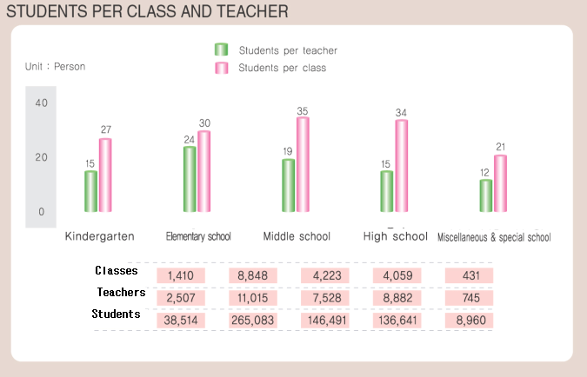
Chart 23. Students per class and teacher in Busan

(2) Employment
1) Economical active population
The Table 12 in numbers of businesses and employees after the economic crisis in 1998 are shown in the following charts.
According to Table 12, among the age group of over 15 on Busan, 1,680,000 (57.89%) were employed. Among the economically active population over 15 years old except the economically inactive population such as students and housewives, unemployment rate was 4.0% in 2004.

Table 66. Economically Active Population (unit : 1,000 persons )
Year | 1) Population 15 years old & over |  |  |  |  |  |  |  | Economic participation rate(%) | Unemploy-  -ment rate  (%)
Year | Total | Economically active population |  |  | Not economically active population |  |  |  | Economic participation rate(%) | Unemploy-  -ment rate  (%)
Year | Total | Total | Employed | Unemployed | Total | House keeping | Attending  school | Others | Economic participation rate(%) | Unemploy-  -ment rate  (%)
1995 | 2,910 | 1,773 | 1,709 | 64 | 1,137 | … | … | … | 60.9 | 3.6
1998 | 2,945 | 1,739 | 1,584 | 155 | 1,206 | … | … | … | 59.0 | 8.9
1999 | 2,947 | 1,729 | 1,572 | 152 | 1,217 | … | … | … | 58.7 | 9.1
2000 | 2,949 | 1,745 | 1,632 | 113 | 1,204 | … | … | … | 59.2 | 6.5
2001 | 2,945 | 1,736 | 1,645 | 91 | 1,209 | 541 | 367 | … | 58.9 | 5.2
2002 | 2,933 | 1,768 | 1,704 | 64 | 1,165 | 528 | 336 | … | 60.3 | 3.6
2003 | 2,919 | 1,674 | 1,610 | 64 | 1,245 | 580 | 342 | … | 57.3 | 3.8
2004 | 2 904 | 1,680 | 1,612 | 68 | 1,224 | 572 | 324 | … | 57.8 | 4.0
Data Source : National Statistical Office
Annual Report on the Economically Active Population Survey」
Note : 1) Soldiers, combatant police, defense corps, prisoners are excluded

▪ Degree of financial independence was lower than Seoul but similar with other cities.

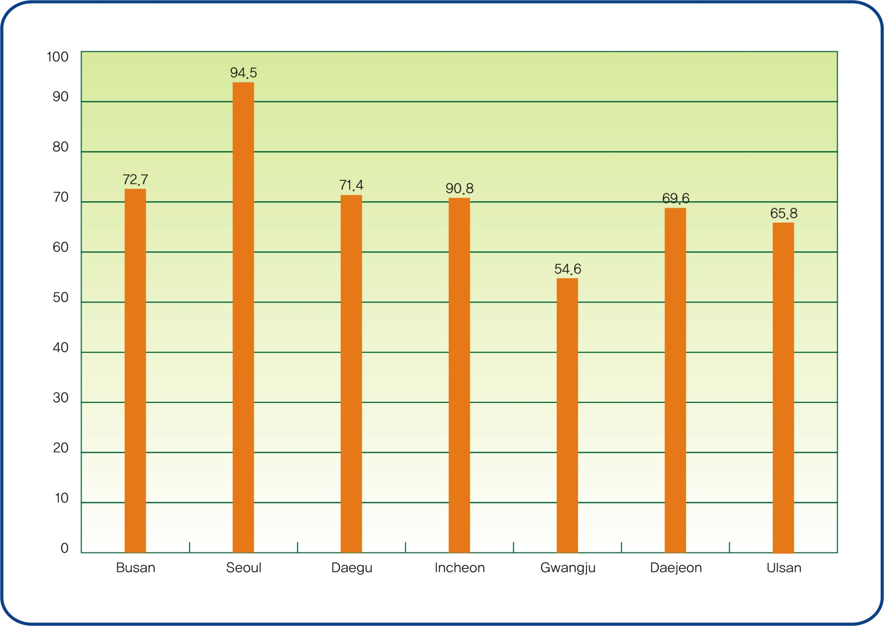
Chart24. Financial independence of major cities

The proportion of absolute poverty bracket is the second highest in Busan city and Daegu city with Gwangju city having the highest.
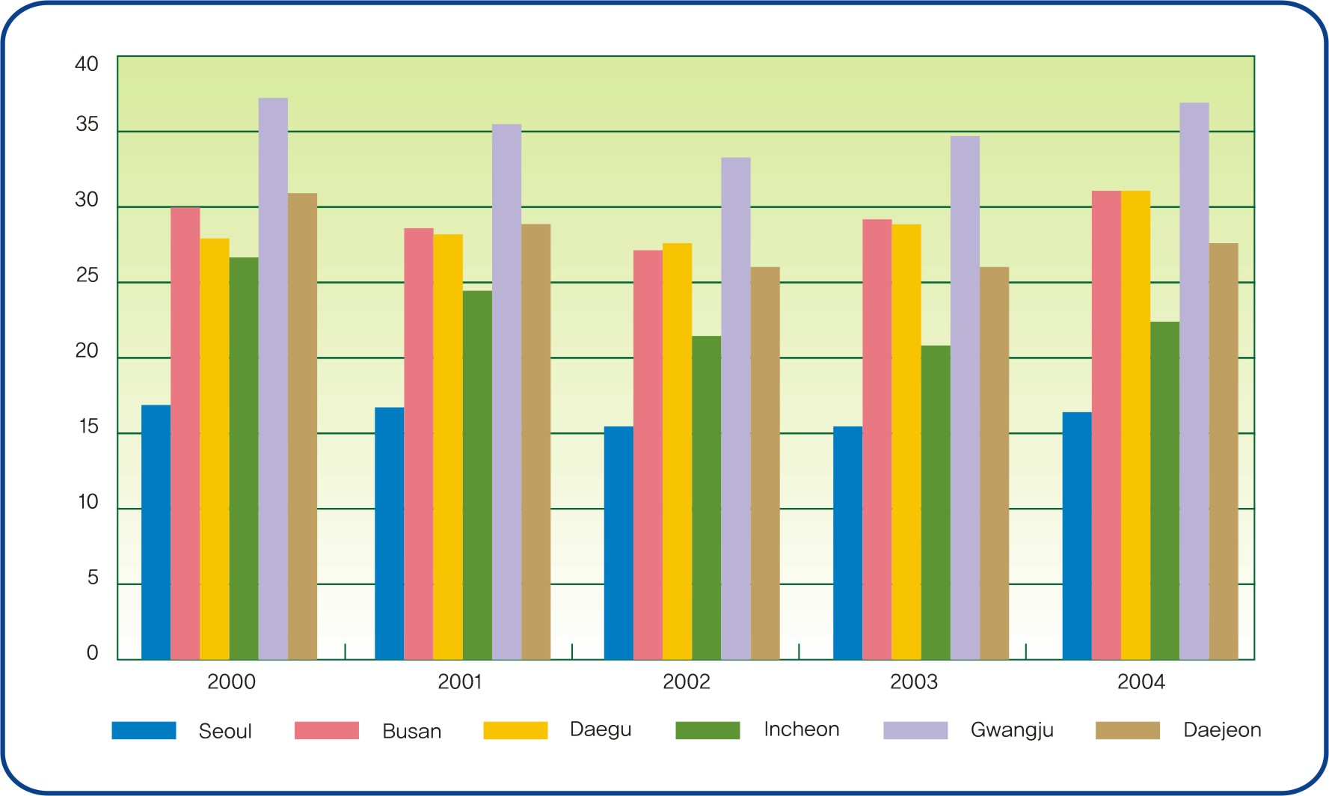
Chart25. The number of recipients of the National basic livelihood security per 1,000 population of major cities
(source : Area statistics of National statistical office)

- Workers and Industry

Table67. Establishments by Industry (unit : Each, Person)
 | Total |  |  |  | By type of organization
 |  |  |  |  | Individuals |  | Corporation  Juridical  person |  | Etc-juridical person |  | Union
 | No. of  Estab  lishment | No. of workers |  |  | No. of  establishment | No. of  workers | No. of  establishment | No. of  workers | No. of  establishment | No. of workers | No. of  establishment | No. of  workers
 | No. of  Estab  lishment | Total | Male | Female
1995 | 256,368 | 1,152,092 | … | … | 13 337 | 388 851 | 3 622 | 133 999 | 3 372 | 21 314 | 3 372 | 21 314
1998 | 249,677 | 1,010,408 | 598,887 | 411,521 | 229,130 | 537,645 | 11,806 | 310,543 | 5,133 | 27,683 | 3,608 | 134,537
1999 | 256,561 | 1,045,176 | 613,637 | 431,539 | 134,208 | 563,256 | 13,251 | 322,386 | 5,459 | 27,647 | 3,643 | 131,887
2000 | 261,480 | 1,057,136 | 611,601 | 445,535 | 237 742 | 577 364 | 14 108 | 320 584 | 3 758 | 133,568 | 5,872 | 25,620
2001 | 262 ,79 | 1,106,971 | 632,804 | 474,115 | 236 846 | 581 883 | 16 248 | 362 785 | 3 954 | 139,356 | 5,531 | 22,893
2002 | 268 ,84 | 1,145,605 | 653,071 | 492,534 | 239 196 | 594 612 | 19 727 | 389 547 | 4 378 | 140,722 | 5,483 | 20,724
2003 | 268 ,39 | 1,130,189 | 643,863 | 486,326 | 237 959 | 581 335 | 19 908 | 385 667 | 4 927 | 143,663 | 5,545 | 19,524
2004 | 267 ,478 | 1,144 ,196 | 652 ,940 | 491 ,256 | 236 701 | 575 181 | 20 062 | 397 963 | 4 709 | 146 ,10 | 6 ,006 | 24 ,42
Data Source : Planning and innovation division
Note : 1) Incorporated company
Unemployment rate of both younger and prime generations among metropolitans was the highest between 2000-2001, but after 2002 similar levels have been maintained.

Table68. Younger generation unemployment rate of major cities. (age 15-29)
 | 2000 | 2001 | 2002 | 2003 | 2004 | 2005
Seoul | 8.1 | 8.4 | 8.3 | 8.8 | 9.0 | 9
Busan | 12.1 | 10.9 | 7.6 | 9.0 | 9.9 | 8.8
Daegu | 9.2 | 9.7 | 9.2 | 9.8 | 8.6 | 8.6
Incheon | 8.1 | 8.3 | 8.0 | 8.8 | 8.2 | 8.3
Gwangju | 11.8 | 9.4 | 7.7 | 10.8 | 9.5 | 9.5
Daejeon | 9.4 | 9.3 | 7.7 | 7.0 | 9.3 | 9.2
Data source : National statistical office, employment statistics

Table69. Prime generation unemployment rate of major cities (age 30-59)
 | 2000 | 2001 | 2002 | 2003 | 2004 | 2005
Seoul | 3.9 | 3.5 | 3 | 3.2 | 3.4 | 3.6
Busan | 5.5 | 4.2 | 2.9 | 2.9 | 3.1 | 3.3
Daegu | 3.8 | 3.5 | 2.9 | 3 | 3.2 | 3.2
Incheon | 4.6 | 3.7 | 2.8 | 2.8 | 2.9 | 3.2
Gwangju | 4.8 | 3.7 | 2.8 | 2.8 | 2.9 | 3.2
Daejeon | 3.4 | 2.9 | 2.6 | 3 | 2.7 | 3.1
Data source : National statistical office, employment statistics

(3) Housing
Among the 962,560 households in Busan, 931,902 families have dwellings, which is 96.8% of all families in 2004.

Tape 70. Type of Housing Units in Busan (unit : House)
 | No. of  House  - holds | Total |  | Housing units
 | No. of  House  - holds | No | (%)  Housing supply rate | Detached dwelling |  | Apartment | Row house | Apartment units  in a private house | Dwelling units in the building not intended for human habitation
 |  |  |  | No | Multi family house
1995 | 1,132,360 | 719, 058 | 72.1 | 325,087 | - | 294,336 | 40, 220 | 59 ,415 | -
2000 | 1,199 ,804 | 870, 426 | 82.2 | 320 ,124 | 160, 200 | 425 ,246 | 41, 750 | 50 ,074 | 33, 232
2001 | 1,210 ,902 | 894, 222 | 83.3 | 318 ,212 | 160, 111 | 443 ,557 | 41, 889 | 57 ,080 | 33, 484
2002 | 960 ,647 | 888, 206 | 92.5 | 264 ,877 | 130, 516 | 478 ,101 | 57, 564 | 59 ,091 | 28, 573
2003 | 962 ,904 | 904,932 | 94.0 | 262 ,671 | 135, 591 | 491 ,635 | 57, 182 | 66 ,829 | 26, 615
2004 | 962 ,560 | 931,902 | 96.8 | 256 ,766 | 130, 905 | 525 ,269 | 54, 314 | 72 ,415 | 23, 138
Data Source : Building Construction ＆ Housing Div. in Busan city hall

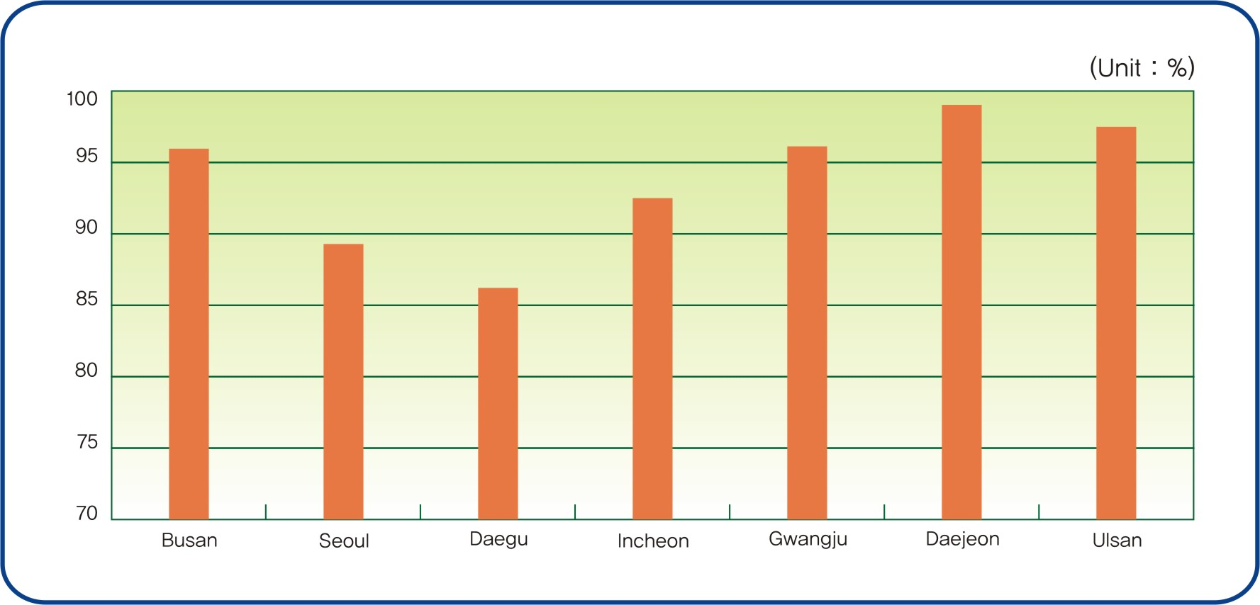
Chart 26. Diffusion ratio of house in major cities

(4) Social Safety

1) Criminal offenses
There were 141,658 criminal cases in Busan 2004. Violence cases numbered 19,276(13.60 %) and intellectual offense cases numbered 22,049(15.56%). There were 5,791 juvenile delinquency cases. Among them, 19,276 cases (13.60%) were violence, 11,692 cases (8.25%) were theft, and 376 cases (27%) were the special law violations. The number of felony offences was 1,126 cases (0.79%). The number of felony offence cases of youth was not high but the percentage in the total felony offence cases on Busan was high at 14.92%.

Table 71. Criminal Offenses, 2004 (unit: case)
Type | Total |  | Juvenile Delinquency |  | Percentage of juvenile delinquency
Type | Cases | % | Cases | % | Percentage of juvenile delinquency
Felony offenses | 1,126 | 0.79 | 168 | 2.90 | 14.92
Thefts | 11,692 | 8.25 | 1,846 | 31.87 | 15.79
Violent offenses | 19,276 | 13.60 | 1,758 | 30.36 | 9.12
Intellectual offenses | 22,049 | 15.56 | 420 | 7.25 | 1.90
Others criminal offenses | 3,848 | 2.71 | 57 | 0.98 | 1.48
Offenses other than criminal code | 83,667 | 59.06 | 1,539 | 26.58 | 1.84
Total | 141,658 | 100.00 | 5,791 | 100.00 | 4.09
Data Sources: Busan(2005). Busan Statistical Year Book. p.485, p.491

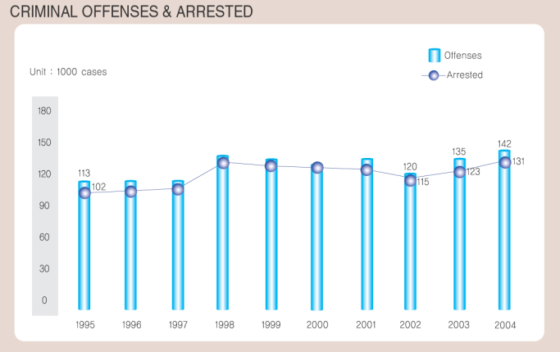
Chart 27. Criminal offenses and arested

2) Traffic accidents and Fire incidents
There were 11,713 traffic accident cases and 1,945 fire incident cases in Busan 2004.
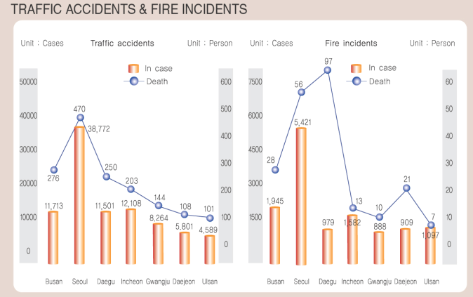
Chart 28. Traffic accidents and fire incidents

▪ According to the car accident statistics of the National Policy Agency, Busan metropolitan's 2003 yearly accident cases was a total of 12,944, 301 deaths, 18,195 injuries. Out of these accidents 1,843 were caused by alcohol drunk driving accounting for 14.2% of the total accidents. Alcohol drunk driving caused 63 deaths which is a 20.93% of the total deaths and 3,151 injuries accounting for 16.59% of the total injuries.
Table72. Status Traffic accidents by regions in 2003. (unit : case, person, %)
 | No. of registered motor vehicles | Total cases of accident |  |  | Accident after alcohol drinking
 | No. of registered motor vehicles | cases of accident | Persons  killed | Injured persons | cases of accident | The distribution ratio | Persons killed | Injured persons
Seoul | 2,776,536 | 40,279 | 504 | 58,677 | 3,798 | 9.4 | 68 | 6,673
Busan | 955,366 | 12,944 | 301 | 18,991 | 1,843 | 14.2 | 63 | 3,151
Daegu | 820,494 | 12,807 | 226 | 18,195 | 2,183 | 17.0 | 54 | 3,681
Incheon | 774,351 | 13,304 | 203 | 20,489 | 1,553 | 11.7 | 31 | 2,898
Gwangju | 414,630 | 8,756 | 158 | 13,109 | 983 | 11.2 | 19 | 1,740
Daejeon | 481,078 | 6,702 | 104 | 10,733 | 1,137 | 17.0 | 18 | 2,093
Ulsan | 359,016 | 4,909 | 119 | 7,070 | 707 | 14.4 | 22 | 1,141
Geonggi | 3,232,963 | 46,542 | 1,320 | 75,589 | 6,729 | 14.5 | 199 | 12,462
Gwangwon | 501,240 | 11,559 | 380 | 19,233 | 1,675 | 14.5 | 70 | 2,943
Chungbuk | 477,486 | 8,639 | 341 | 13,860 | 979 | 11.3 | 50 | 1,747
Chungnam | 602,433 | 9,506 | 533 | 15,490 | 1,493 | 15.7 | 99 | 2,759
Jeonbuk | 567,026 | 10,962 | 476 | 18,085 | 1,231 | 11.2 | 65 | 2,283
Jeonnam | 553,348 | 11,919 | 571 | 19,119 | 1,600 | 13.4 | 91 | 2,781
Geongbuk | 889,786 | 18,408 | 804 | 27,550 | 2,821 | 15.3 | 159 | 4,811
Geongnam | 981,066 | 14,143 | 526 | 20,437 | 2,081 | 15.4 | 90 | 3,386
Busan | 199,976 | 3,609 | 120 | 5,386 | 414 | 12.5 | 15 | 681
Nationwide | 14,586,795 | 240,832 | 7,212 | 376,503 | 31,227 | 13.0 | 1,113 | 55,230
Data source : National Policy Agency

▪ According to the 2004 Korea Insurance Development Institute records, car accidents which consists a felony show a 16.7% of the total car accidents which occur in Busan. This percentage is the second highest, Gwangju city being the first, among the total metropolitans there are nation wide including Seoul city. Among the car accidents which consists a felony, accidents committed by violation of traffic lights was the highest and in following order; drunk driving accidents, violation of central line accidents, cross-walk accidents.

Table73. Status Traffic accidents by regions. (unit : person, %)
 | Rate of accident |  | Persons killed/ 1,000 car |  | Injured persons/1,000 car
 | FY'02 | FY'03 | FY'02 | FY'03 | FY'02 | FY'03
Seoul | 5.2 | 5.7 | 0.2 | 0.2 | 77 | 85
Busan | 4.1 | 4.4 | 0.4 | 0.3 | 57 | 64
Daegu | 3.8 | 4.4 | 0.3 | 0.3 | 54 | 62
Incheon | 6.2 | 6.7 | 0.3 | 0.3 | 93 | 102
Gwangju | 4.3 | 4.9 | 0.4 | 0.4 | 64 | 73
Daejeon | 5.8 | 6.1 | 0.3 | 0.3 | 89 | 95
Ulsan | 3.6 | 4.0 | 0.3 | 0.3 | 51 | 57
Geonggi | 5.2 | 5.7 | 0.4 | 0.3 | 79 | 88
Gwangwon | 4.1 | 4.2 | 0.6 | 0.5 | 65 | 68
Chungbuk | 4.0 | 4.3 | 0.6 | 0.5 | 61 | 68
Chungnam | 4.4 | 4.7 | 0.8 | 0.7 | 70 | 76
Jeonbuk | 5.2 | 5.6 | 0.6 | 0.6 | 82 | 92
Jeonnam | 3.8 | 3.9 | 0.8 | 0.6 | 57 | 61
Geongbuk | 3.6 | 3.8 | 0.7 | 0.6 | 53 | 57
Geongnam | 3.3 | 3.6 | 0.4 | 0.4 | 48 | 53
Busan | 2.8 | 2.8 | 0.5 | 0.5 | 40 | 41
Nationwide | 4.8 | 5.2 | 0.4 | 0.4 | 71 | 79
Data source : Korea Insurance Development Institute

